**VISVESVARAYA TECHNOLOGICAL UNIVERSITY**

**“JnanaSangama”, Belgaum -590014, Karnataka.**



**LAB REPORT**

**on**

COMPUTER NETWORKS

***Submitted by***

**PURVIK C (1BM21CS149)**

***in partial fulfillment for the award of the degree of***

**BACHELOR OF ENGINEERING**

***in***

**COMPUTER SCIENCE AND ENGINEERING**



**B.M.S. COLLEGE OF ENGINEERING**

**(Autonomous Institution under VTU)**

**BENGALURU-560019 JUN-2023 to SEP-2023**

**B. M. S. College of Engineering,**

**Bull Temple Road, Bangalore 560019**

(Affiliated To Visvesvaraya Technological University, Belgaum)

**Department of Computer Science and Engineering**

**CERTIFICATE**

This is to certify that the Lab work entitled “**COMPUTER NETWORKS**” carried out by **PURVIK C(1BM21CS149),** who is bonafide student of **B. M. S. College of Engineering.** It is in partial fulfillment for the award of **Bachelor of Engineering in Computer Science and Engineering** of the Visvesvaraya Technological University, Belgaum during the year 2023. The Lab report has been approved as it satisfies the academic requirements in respect of a **Computer Networks - (22CS4PCCON**)work prescribed for the said degree.

Dr. Nandini Vineeth **Dr. Jyothi S Nayak**

Assistant Professor Professor and Head

Department of CSE Department of CSE

BMSCE, Bengaluru BMSCE, Bengaluru

`

**Index**

|  |  |  |  |
| --- | --- | --- | --- |
| **Sl.**  **No.** | **Date** | **Experiment Title** | **Page No.** |
|  |  | **CYCLE 1** |  |
| 1 | 15-06-23 | Create a topology and simulate sending a simple PDU from source to destination using hub and switch as connecting devices and demonstrate ping message. | 4 |
| 2 | 22-06-23 | Configure IP address to routers in packet tracer. Explore the following messages: ping responses, destination unreachable, request timed out, reply | 12 |
| 3 | 13-07-23 | Configure default route, static route to the Router | 19 |
| 4 | 13-07-23 | Configure DHCP within a LAN and outside LAN | 23 |
| 5 | 20-07-23 | Configure Web Server, DNS within a LAN | 30 |
| 6 | 20-07-23 | Configure RIP routing Protocol in Routers | 33 |
| 7 | 27-07-23 | Configure OSPF routing protocol | 37 |
| 8 | 03-08-23 | To construct simple LAN and understand the concept and operation of Address Resolution Protocol (ARP) | 42 |
| 9 | 10-08-23 | To construct a VLAN and make the PC’s communicate among a VLAN | 45 |
| 10 | 10-08-23 | Demonstrate the TTL/ Life of a Packet | 48 |
| 11 | 10-08-23 | To construct a WLAN and make the nodes communicate wirelessly | 52 |
| 12 | 10-08-23 | To understand the operation of TELNET by accessing the router in server room from a PC in IT office. | 55 |
|  |  | **CYCLE 2** |  |
| 13 | 17-08-23 | Write a program for error detecting code using CRCCCITT (16-bits) | 59 |
| 14 | 17-08-23 | Write a program for congestion control using Leaky bucket algorithm | 64 |
| 15 | 24-08-23 | Using TCP/IP sockets, write a client-server program to make client sending the file name and the server to send back the contents of the requested file if present. | 67 |
| 16 | 24-08-23 | Using UDP sockets, write a client-server program to make client sending the file name and the server to send back the contents of the requested file if present | 74 |

## EXPERIMENT-1

**Q) Create a topology and simulate sending a simple PDU from source to destination using hub and switch as connecting devices and demonstrate ping message.**

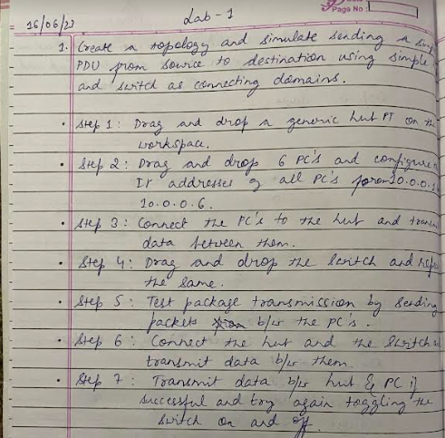

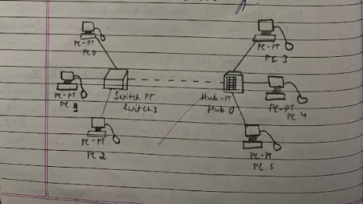

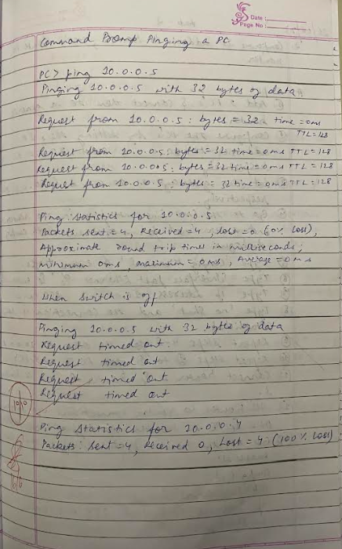

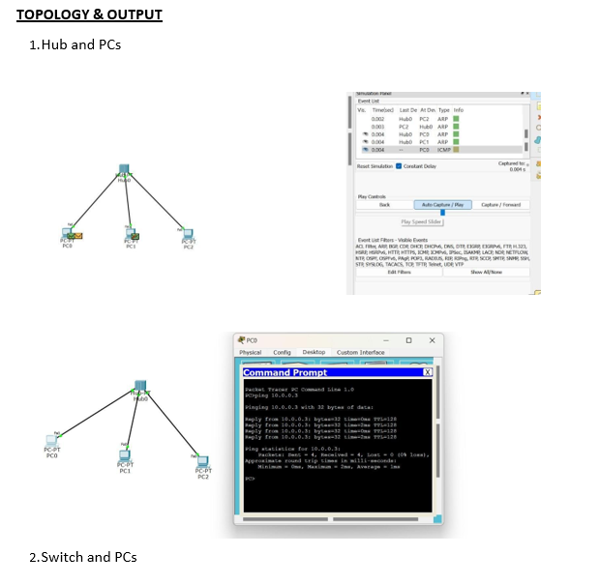

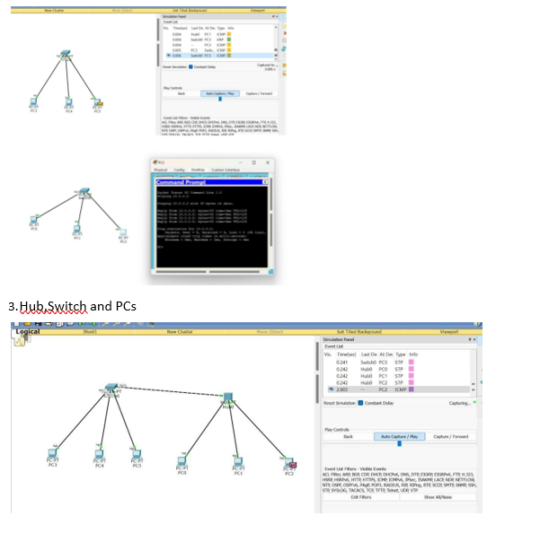

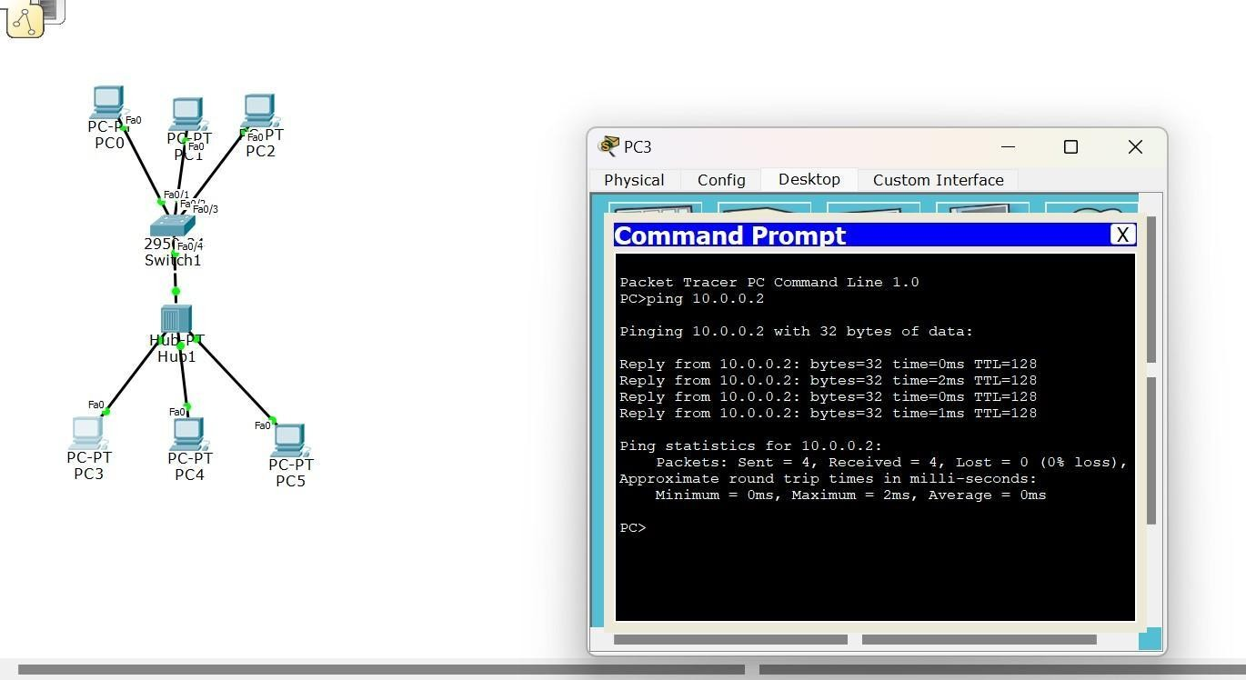

## EXPERIMENT-2

**Q)Configure IP address to routers in packet tracer. Explore the following messages: ping responses, destination unreachable, request timed out, reply**

**PROGRAM 2.1**

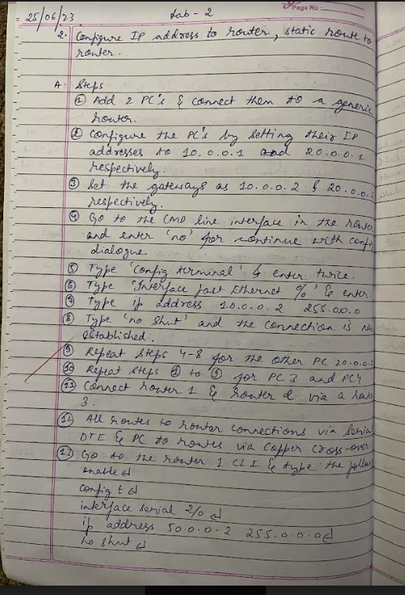

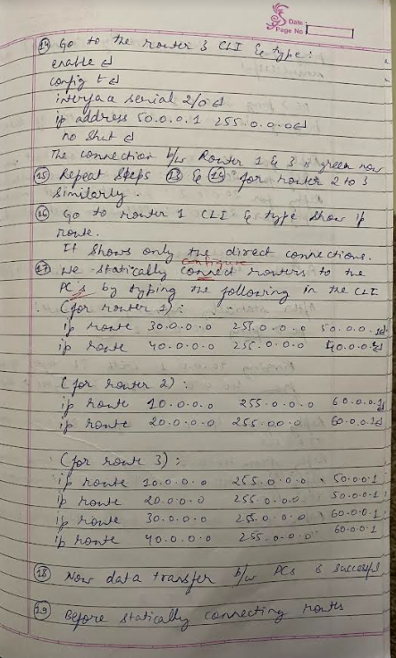

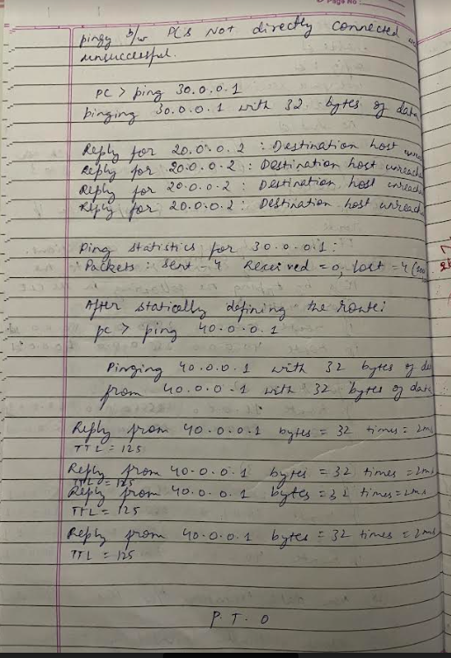

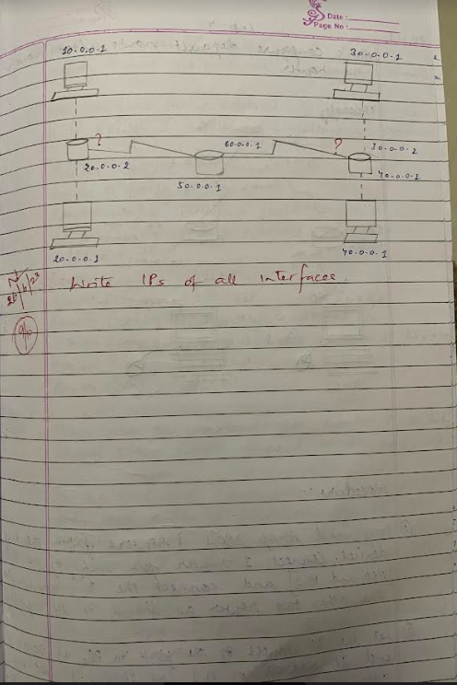

**TOPOLOGY &OUTPUT**

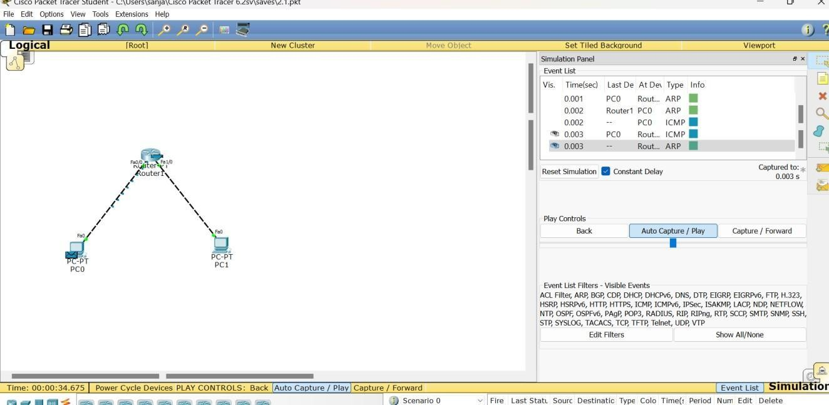

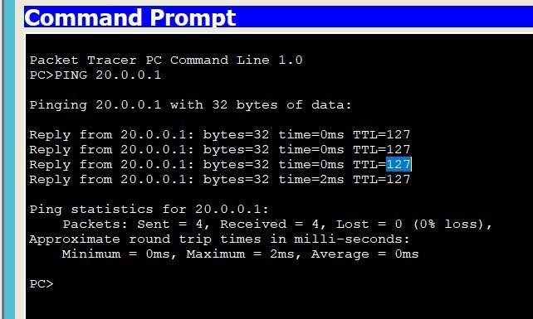

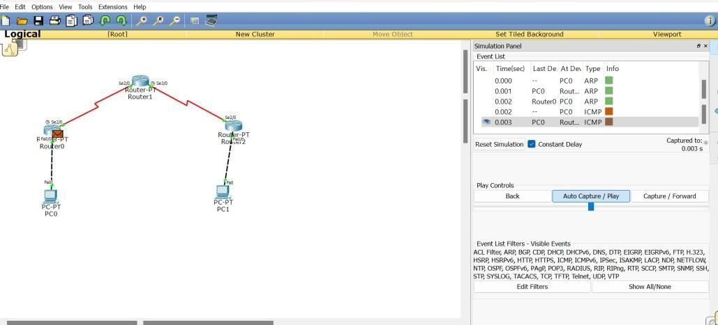

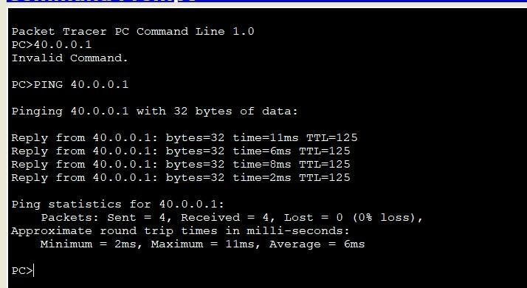

## EXPERIMENT-3

**Q)Configure default route, static route to the Router**

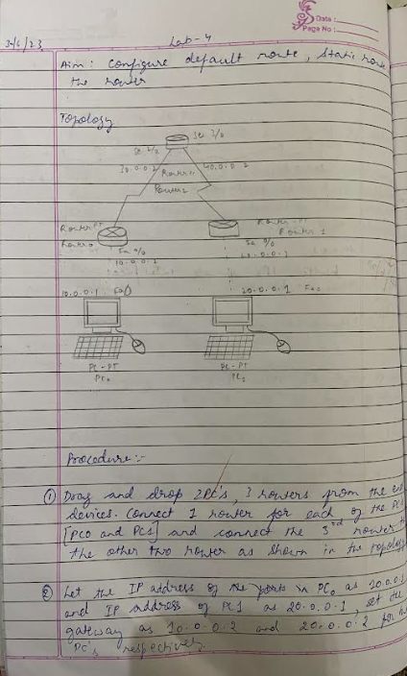

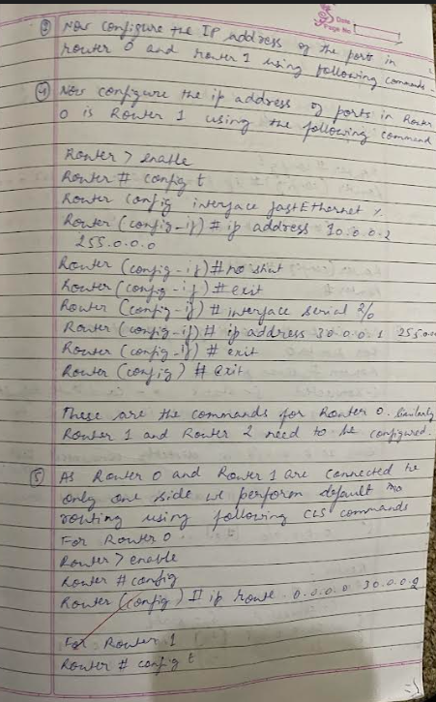

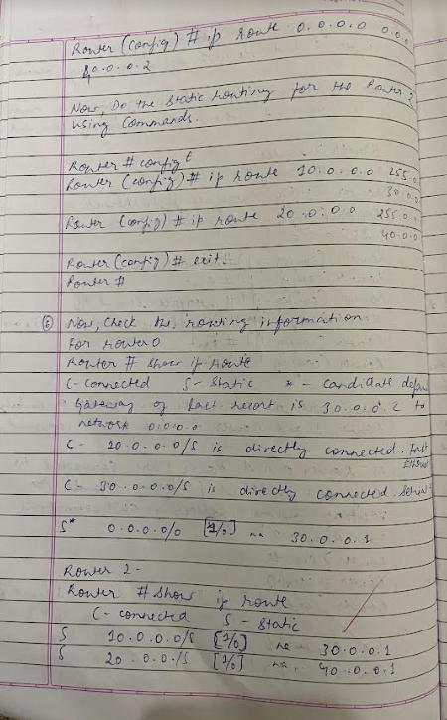

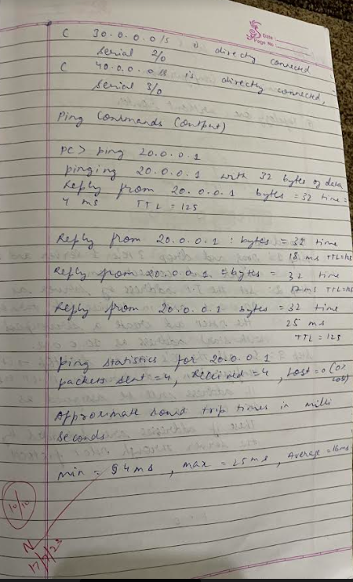

**TOPOLOGY & OUTPUT**

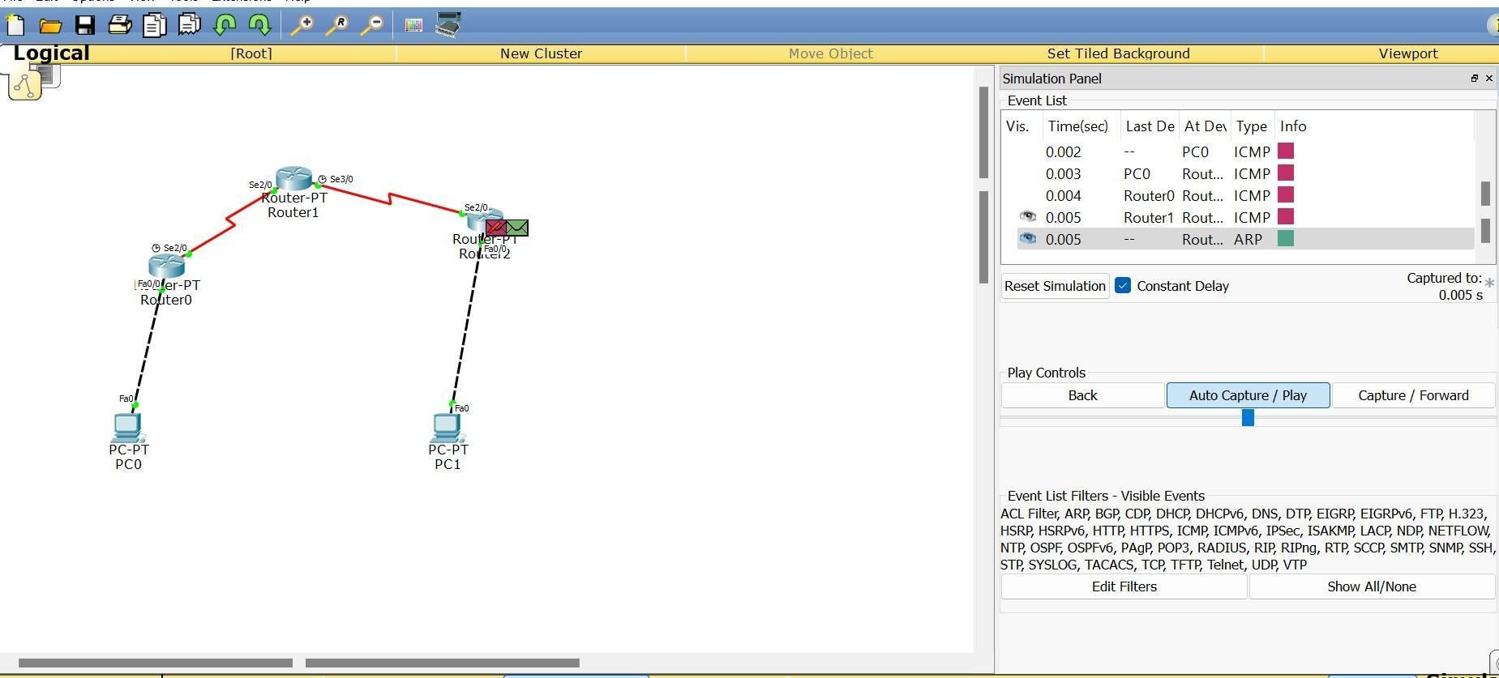

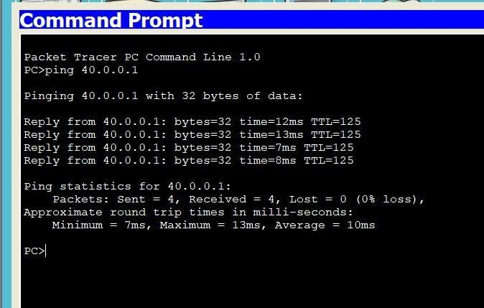

## EXPERIMENT-4

**Q) Configure DHCP within a LAN and outside LAN**

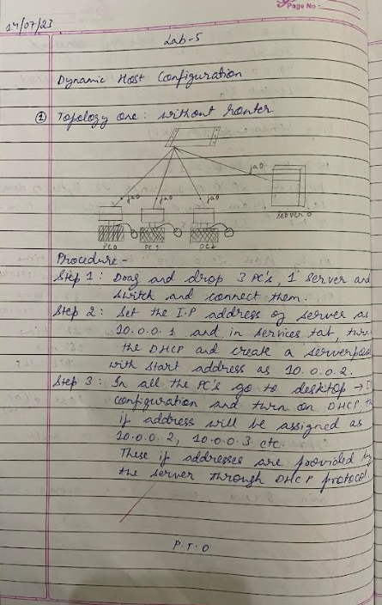

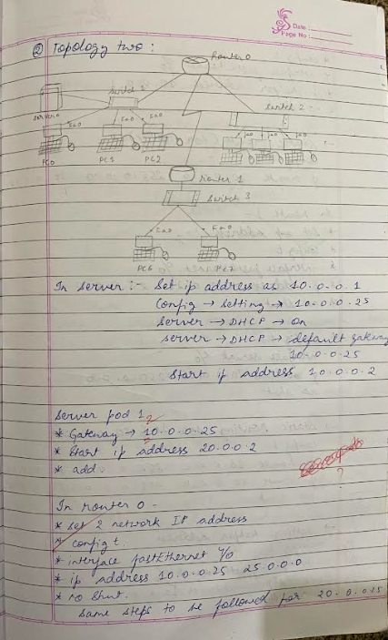

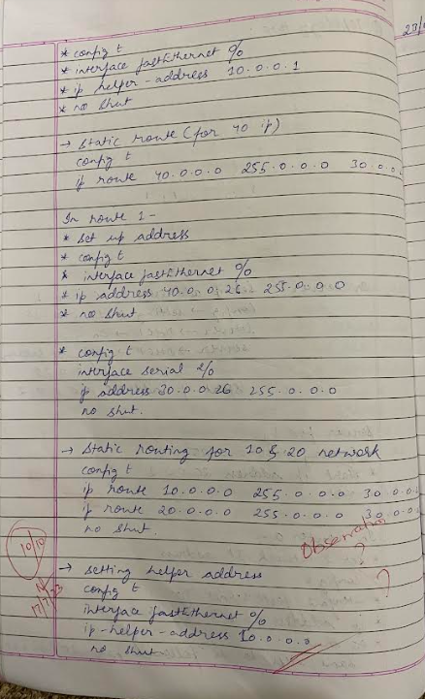

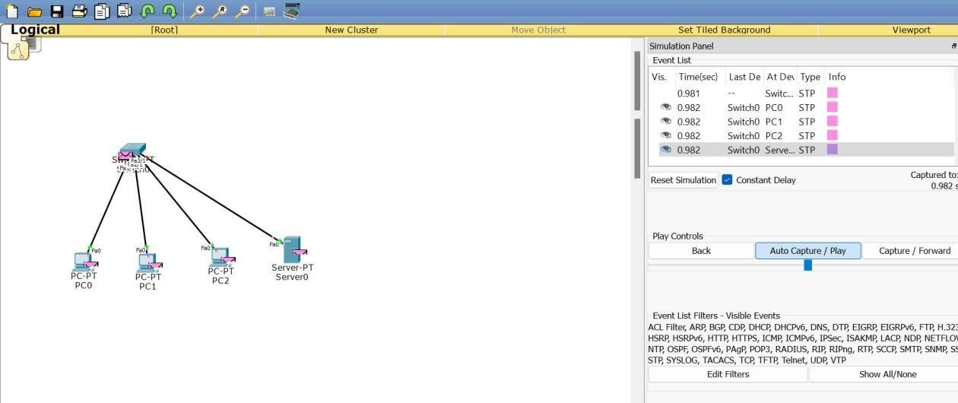

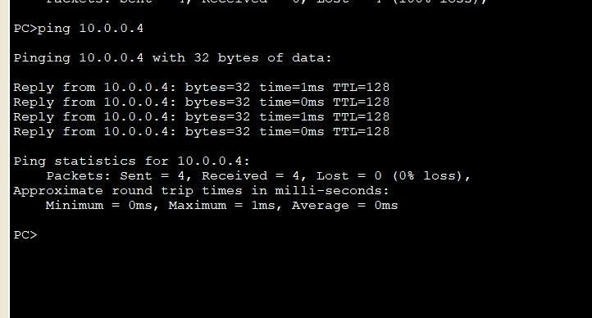

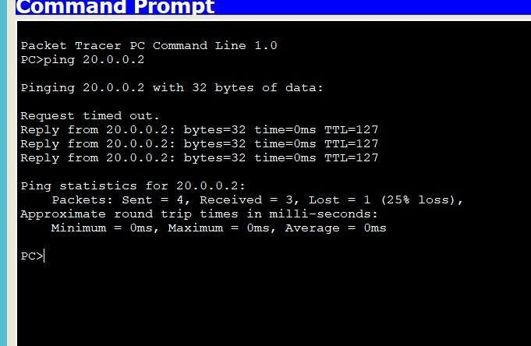

## EXPERIMENT-5

**Q) Configure Web Server, DNS within a LAN**

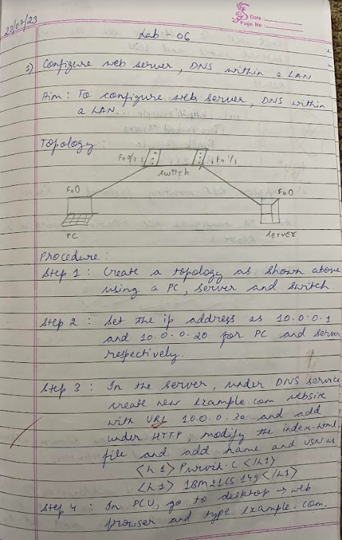

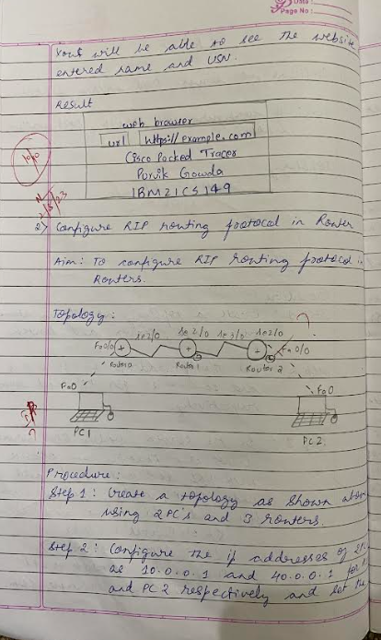

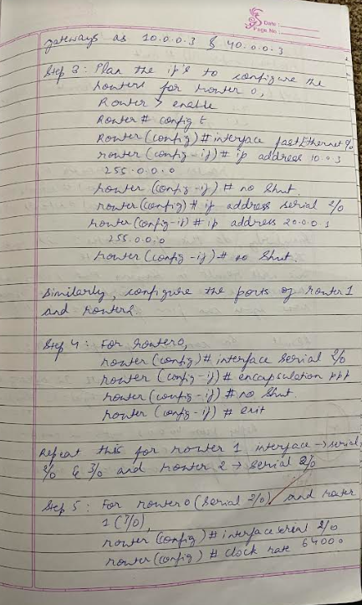

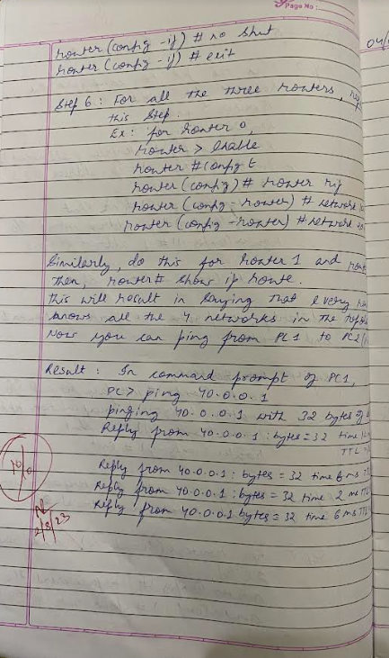

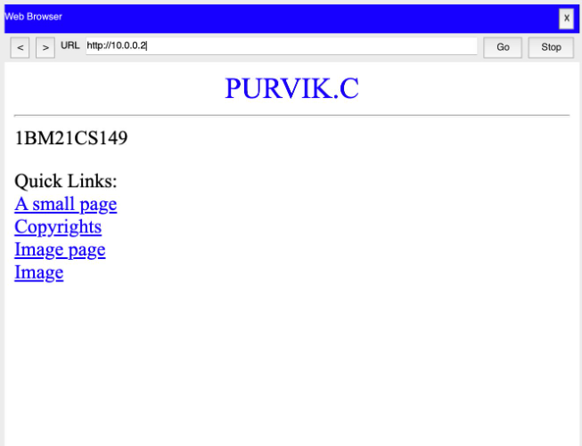

## EXPERIMENT-6

**Q) Configure RIP routing Protocol in Routers**

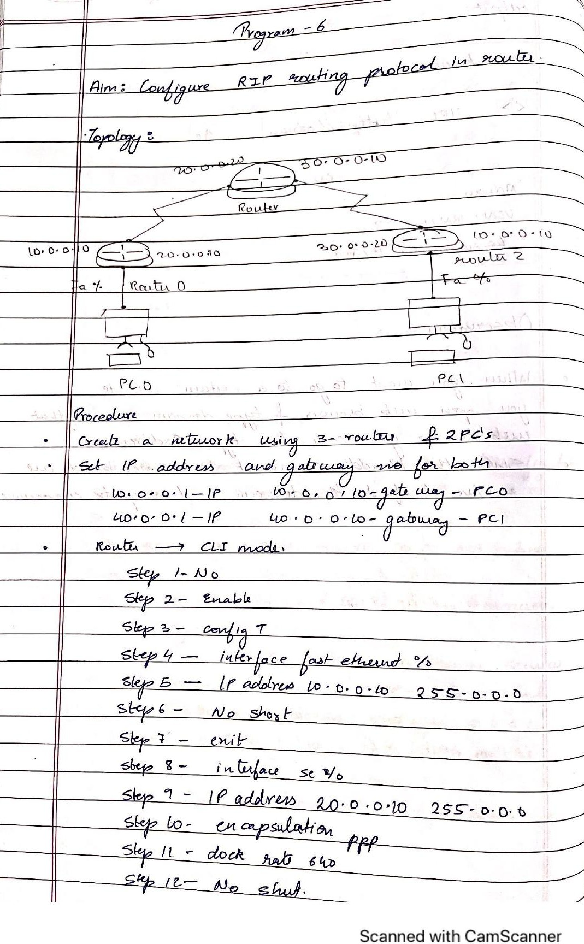

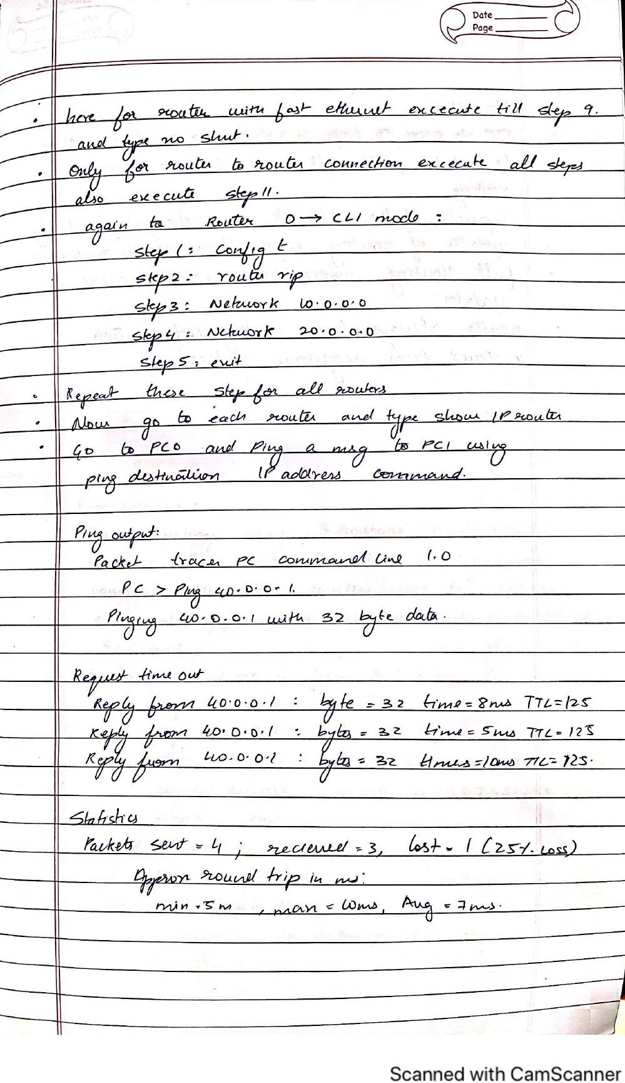

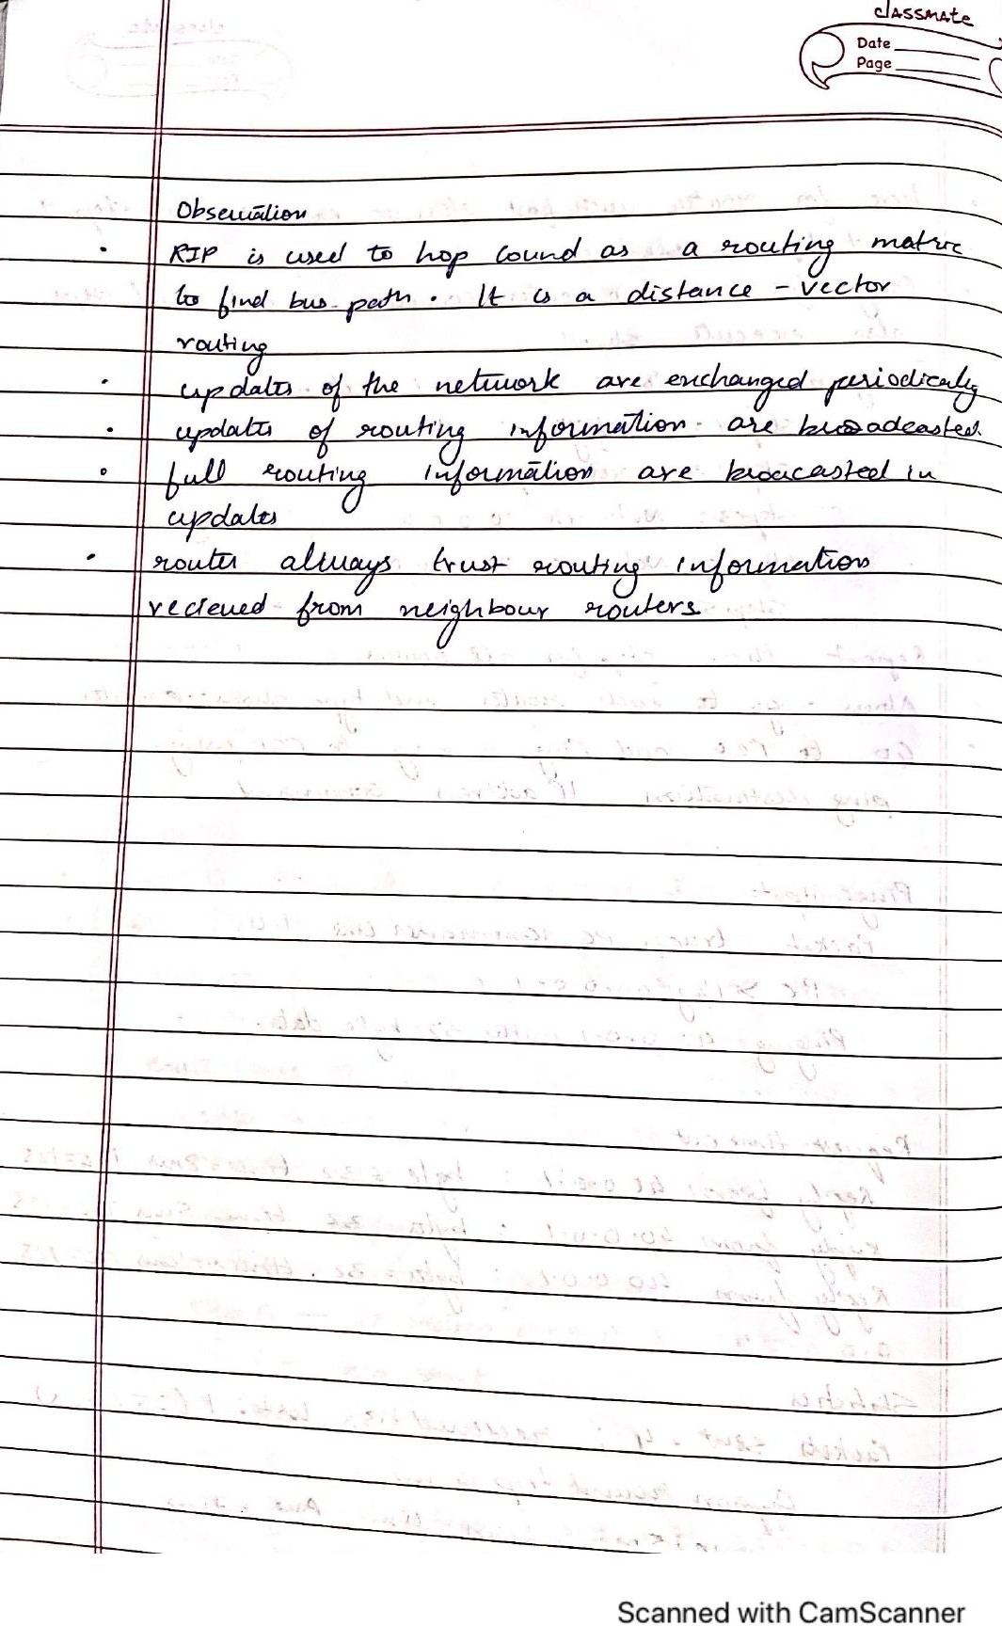

**TOPOLOGY & OUTPUT**

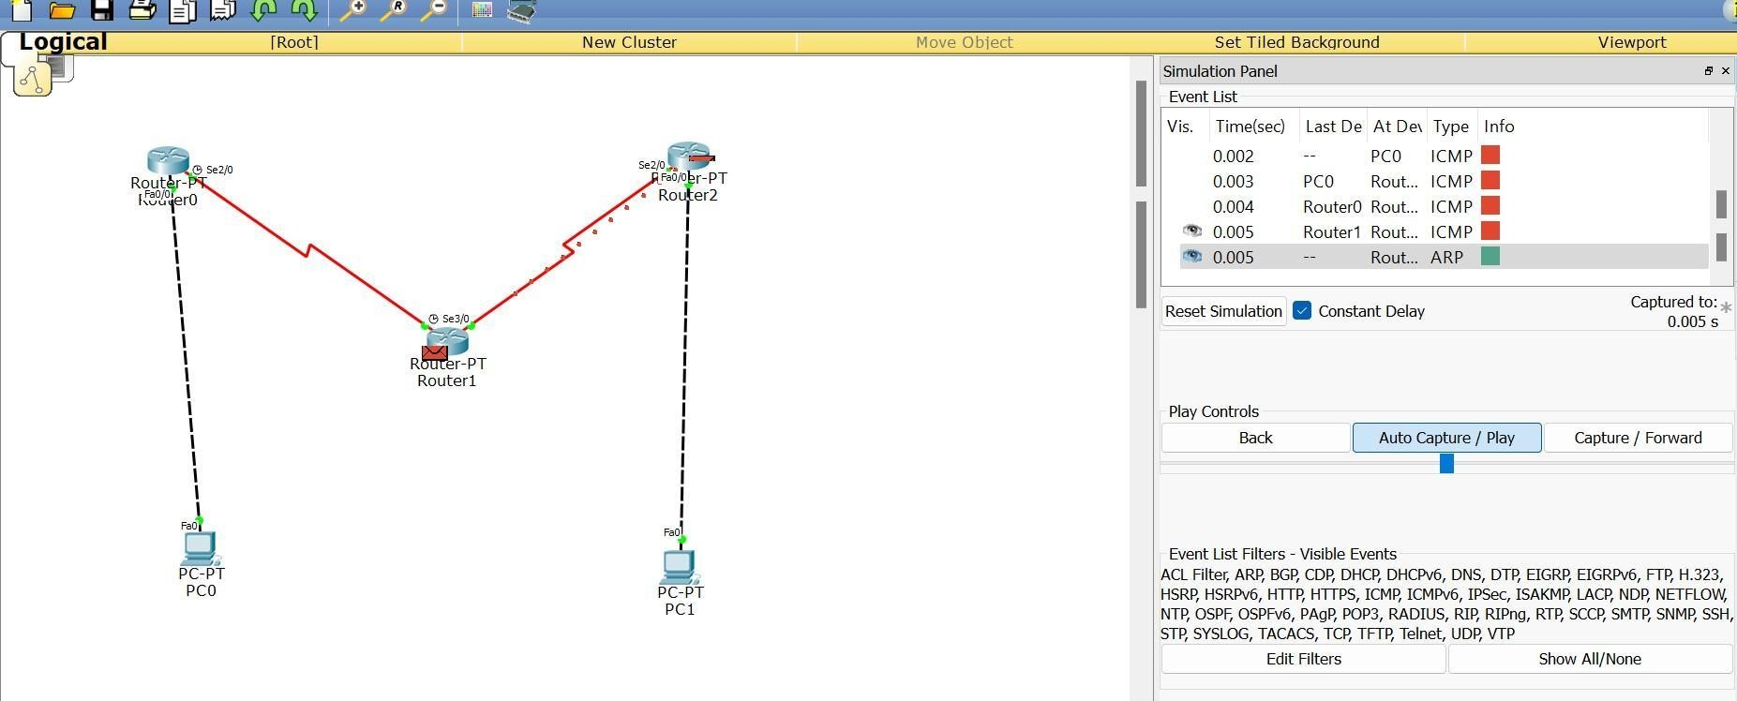

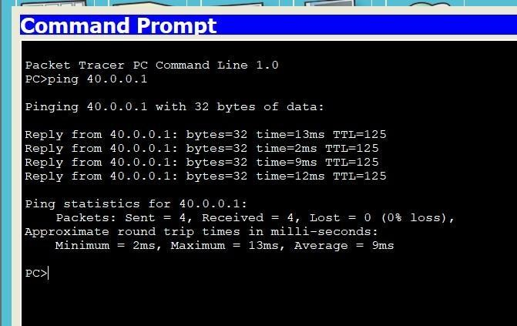

## EXPERIMENT-7

**Q) Configure OSPF routing protocol**

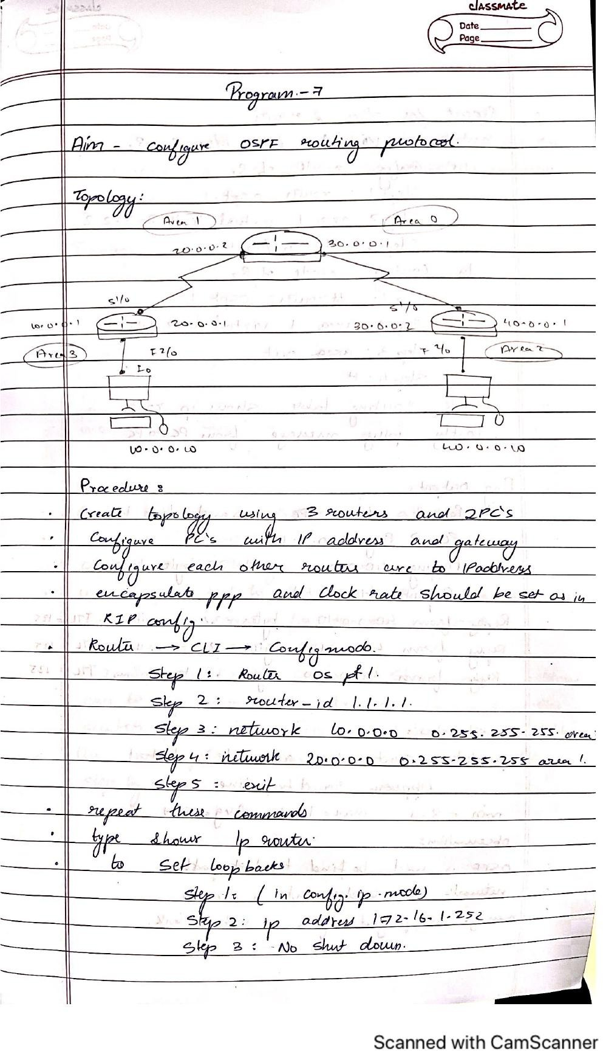

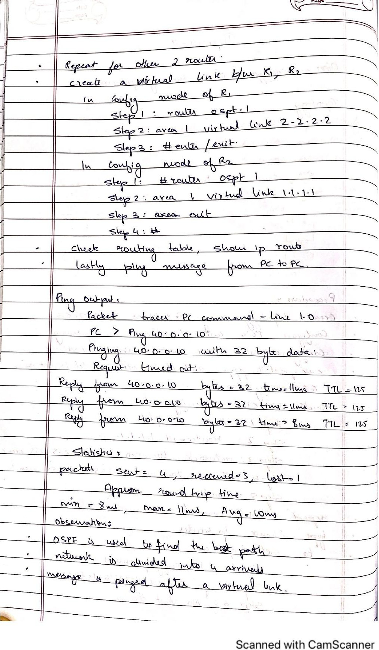

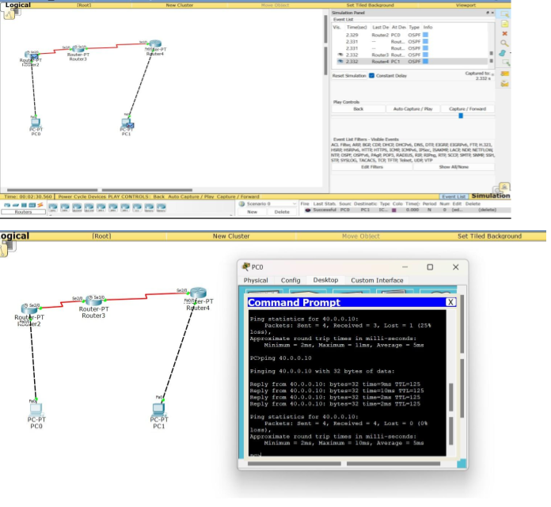**TOPOLOGY & OUTPUT**

## EXPERIMENT-8

**Q) To construct simple LAN and understand the concept and operation of Address Resolution Protocol (ARP)**

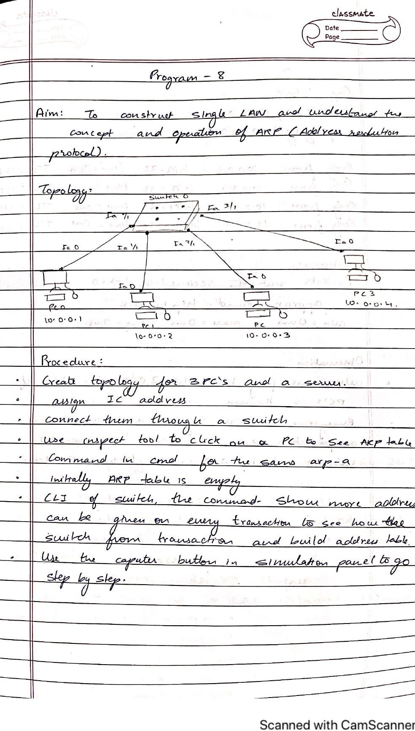

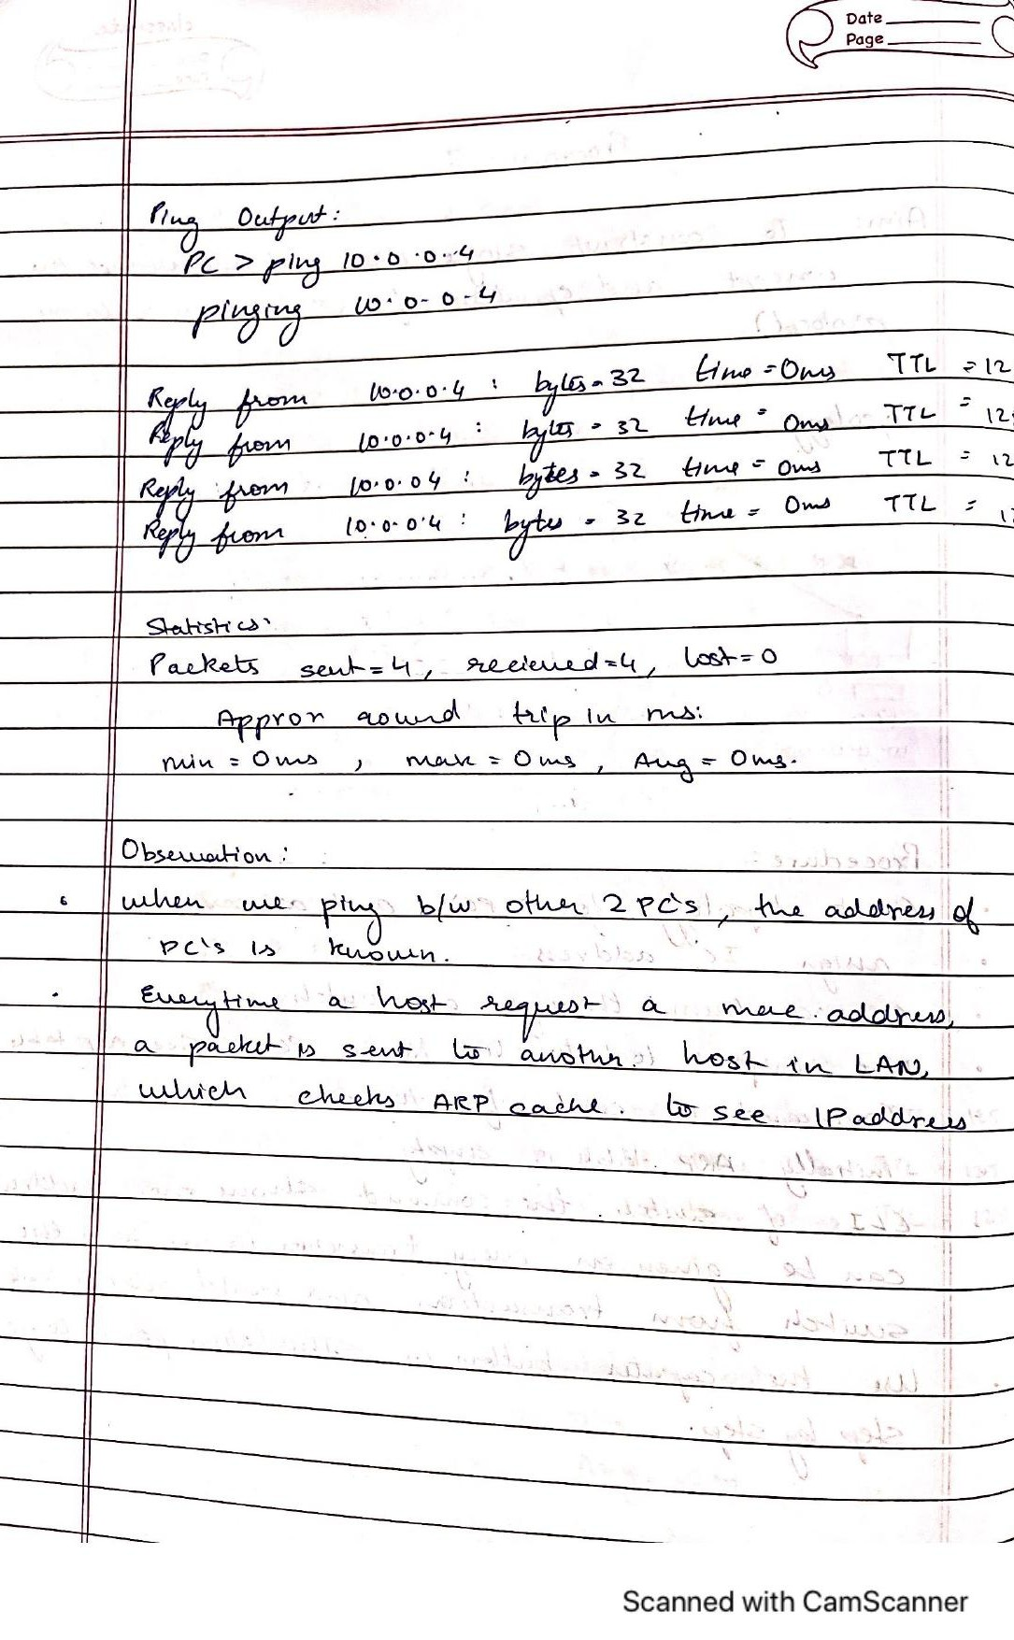

# TOPOLOGY & OUTPUT

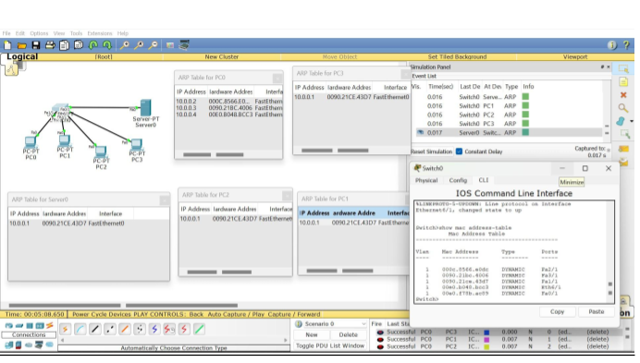

## EXPERIMENT-9

**Q) To construct a VLAN and make the PC’s communicate among a VLAN**

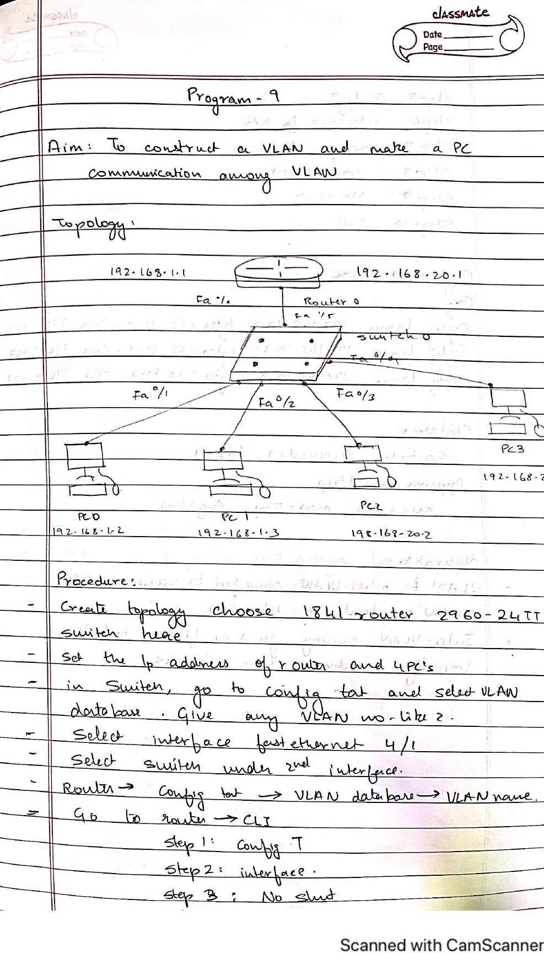

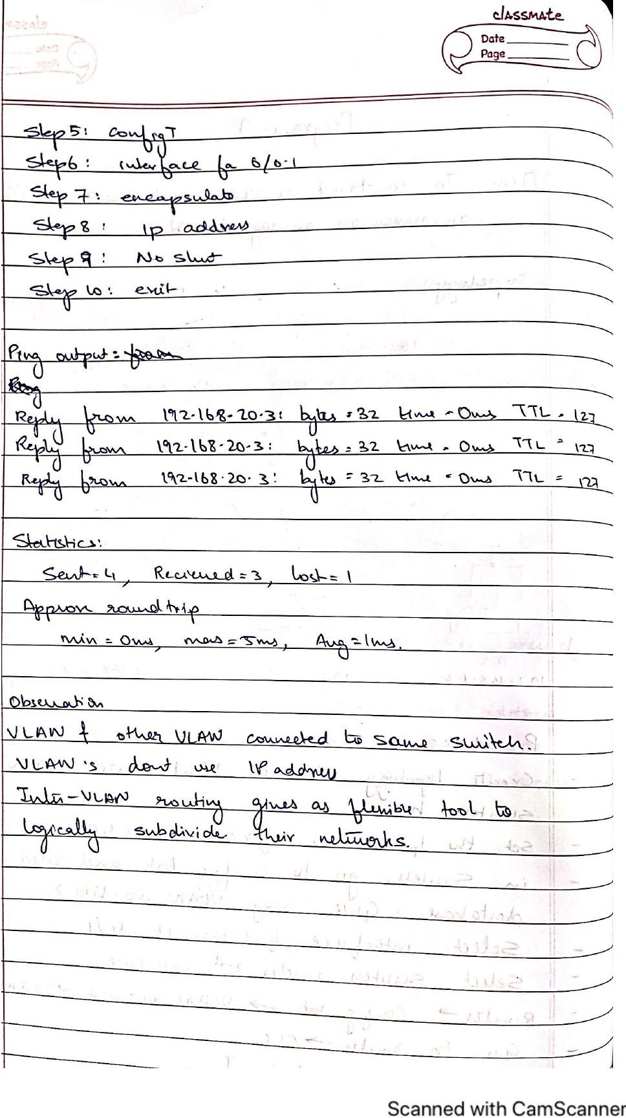

**TOPOLOGY & OUTPUT**

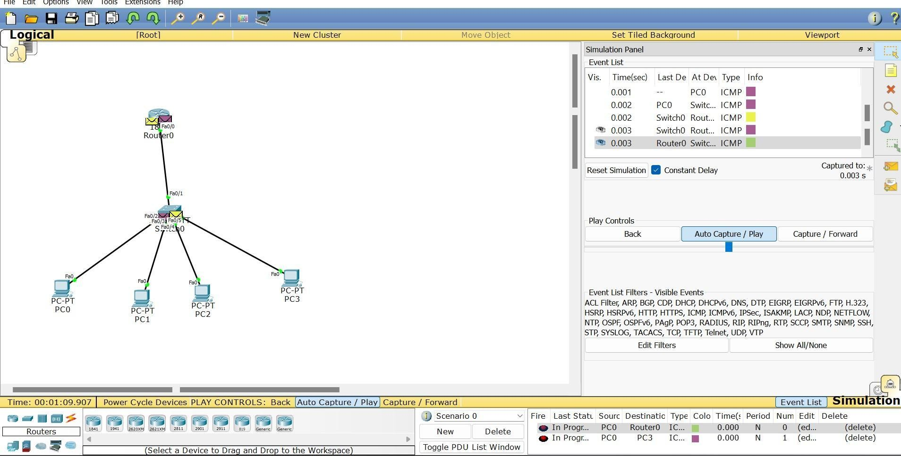

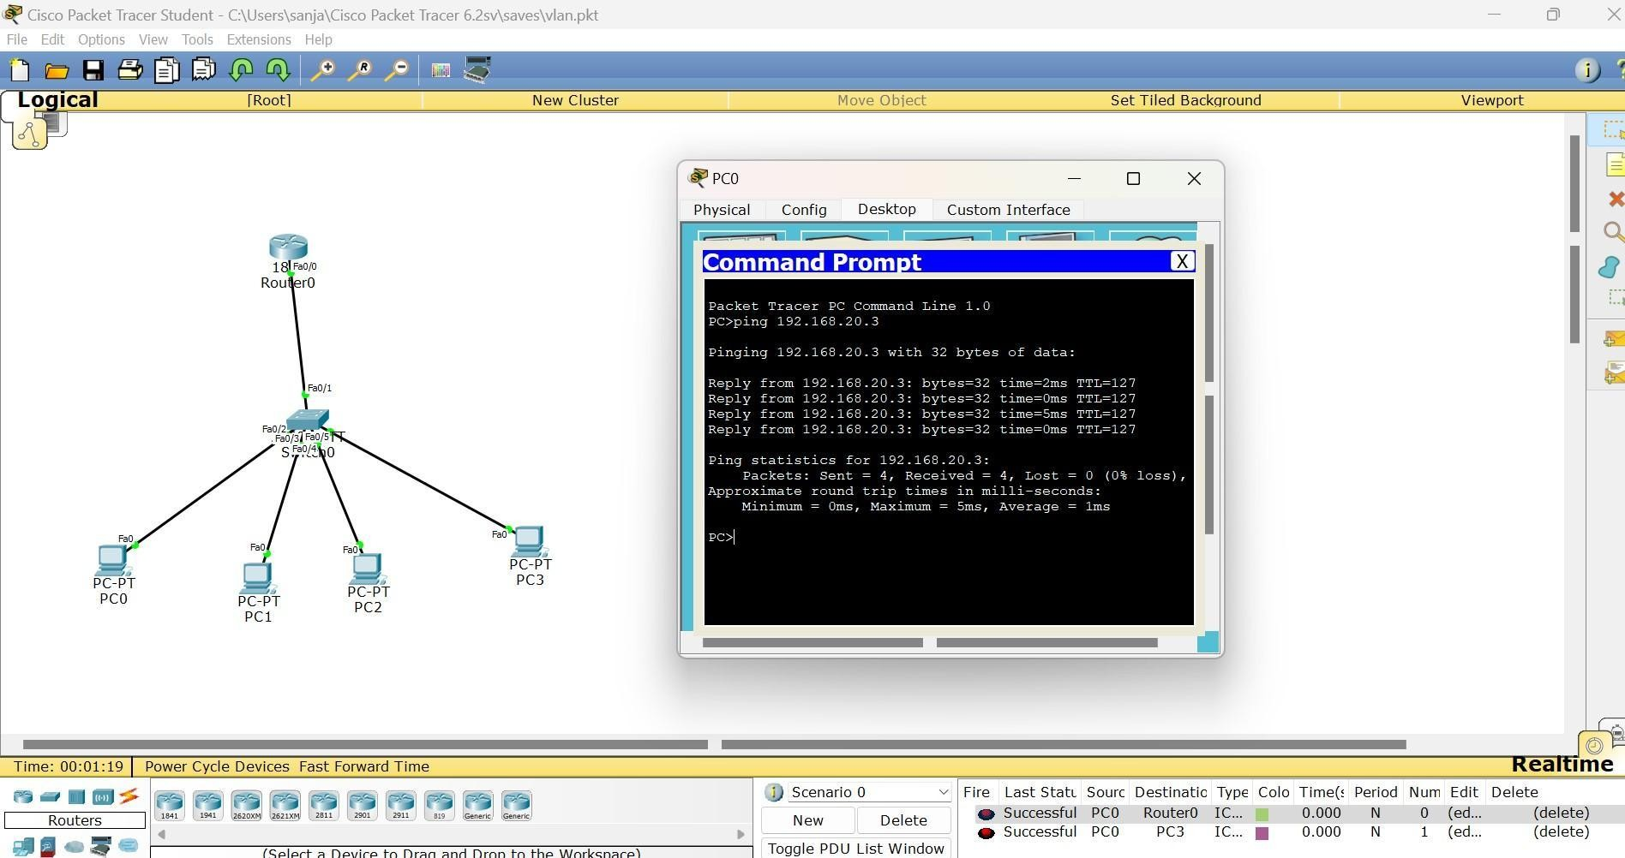

## EXPERIMENT-10

**Q) Demonstrate the TTL/ Life of a Packet**

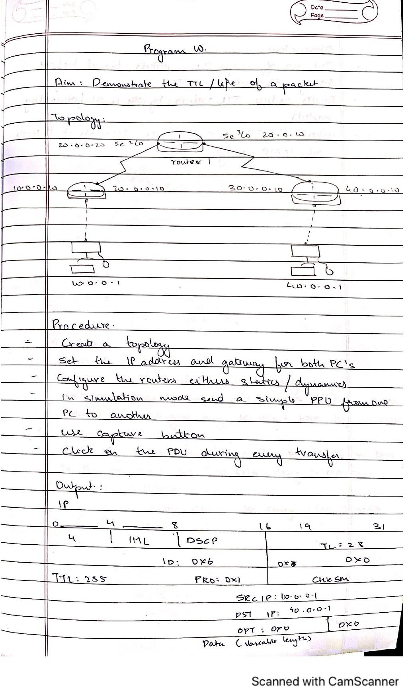

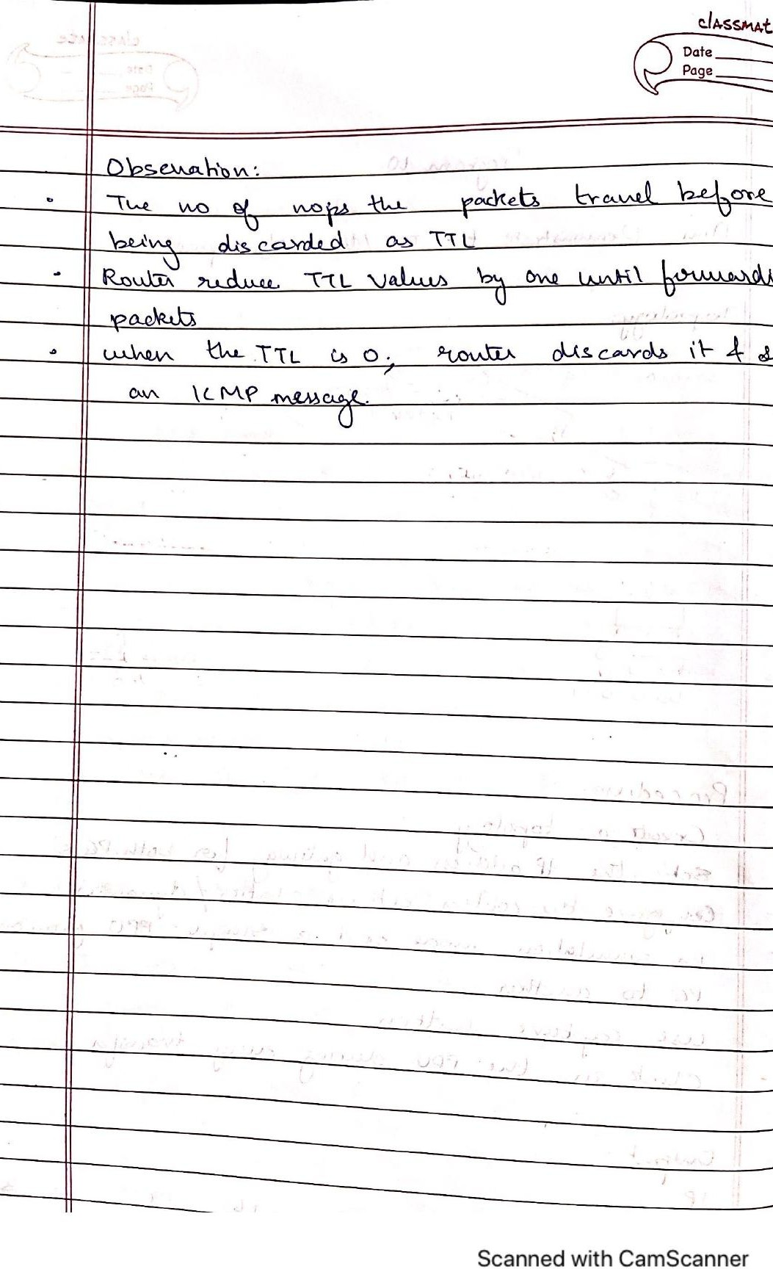

**TOPOLOGY & OUTPUT**

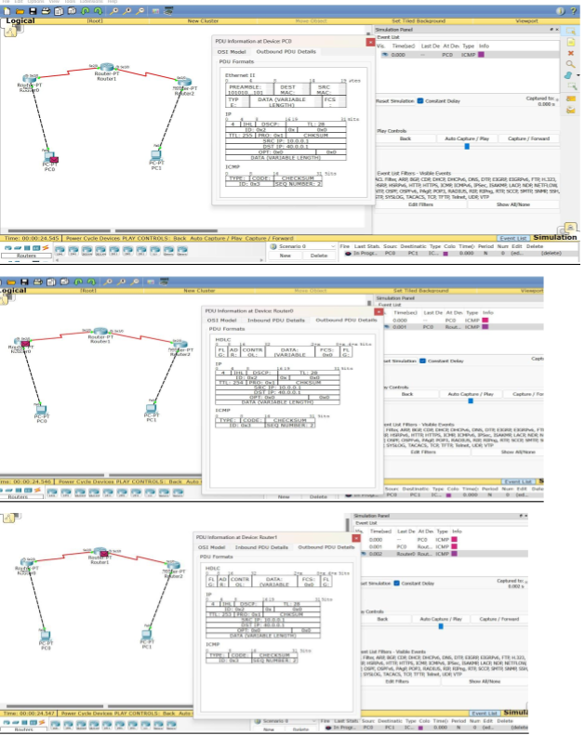

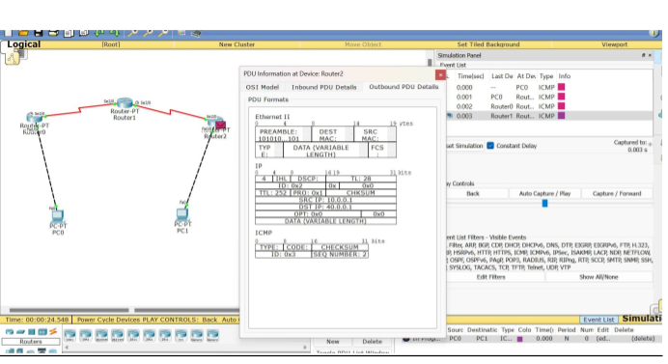

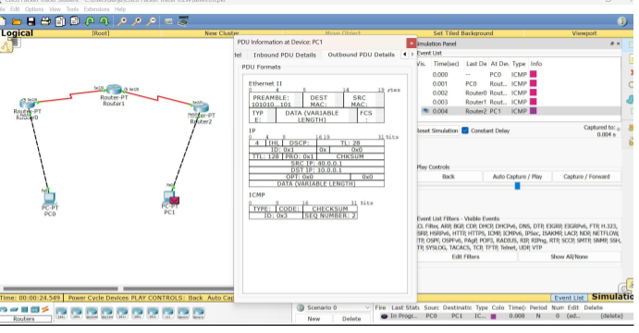

## EXPERIMENT-11

**Q) To construct a WLAN and make the nodes communicate wirelessly**

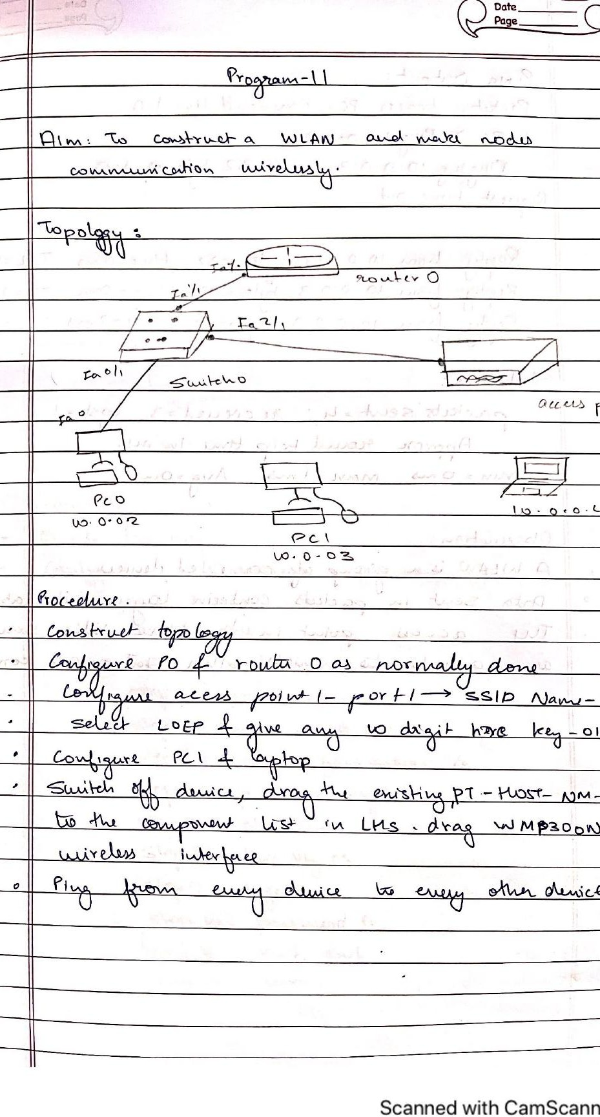

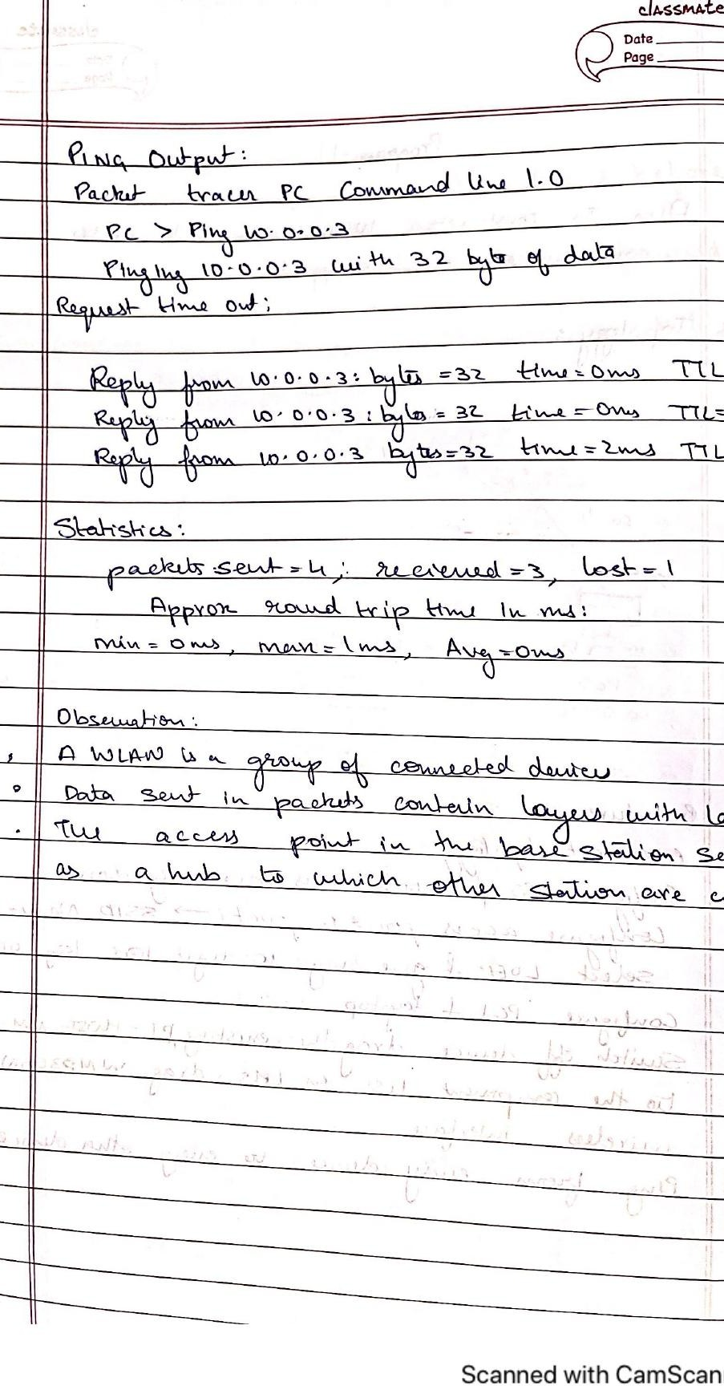

# TOPOLOGY & OUTPUT

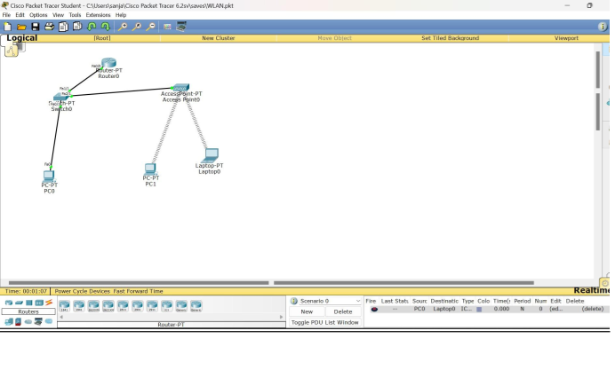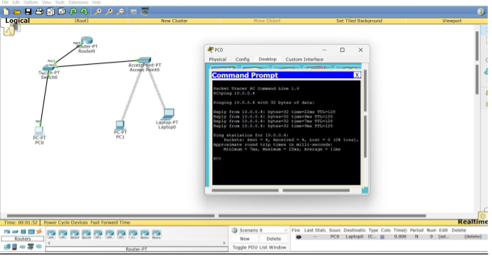

## EXPERIMENT-12

**Q) To understand the operation of TELNET by accessing the router in server room from a PC in IT office.**

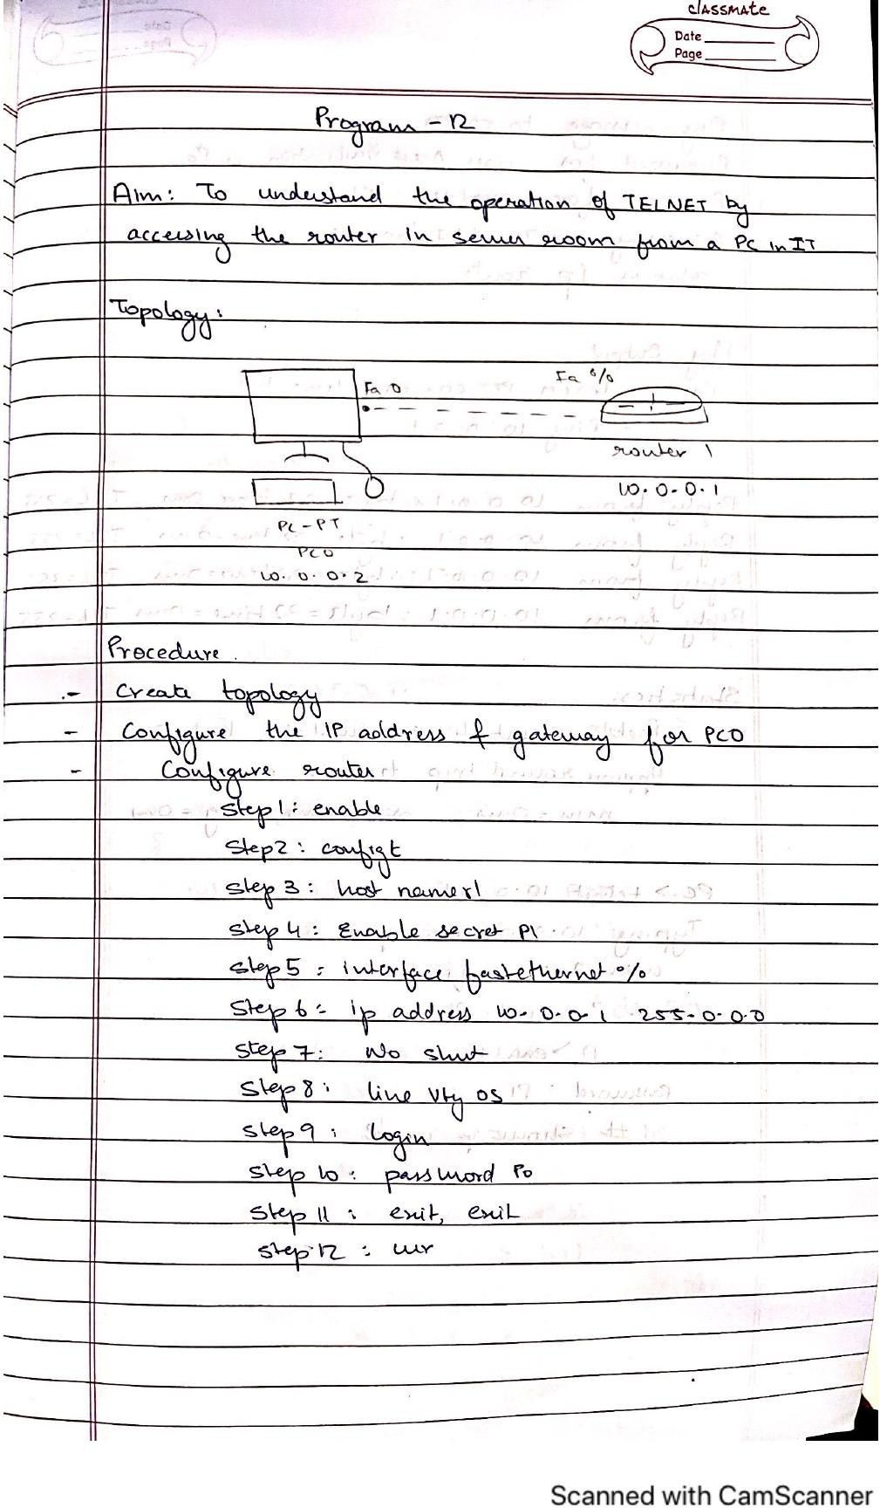

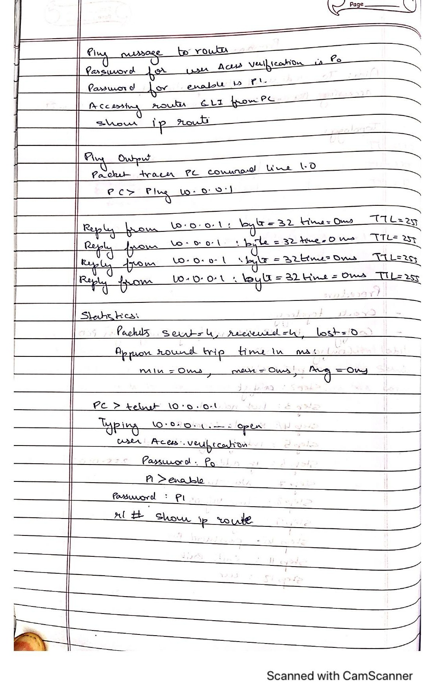

54

**TOPOLOGY & OUTPUT**

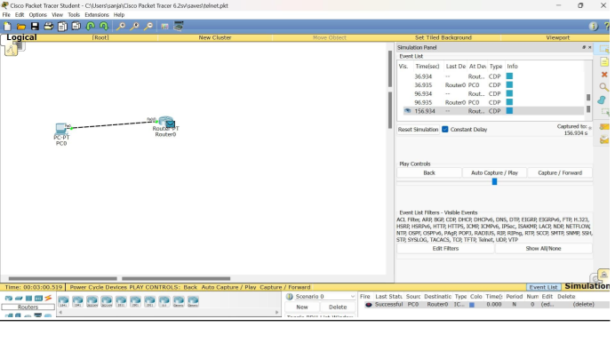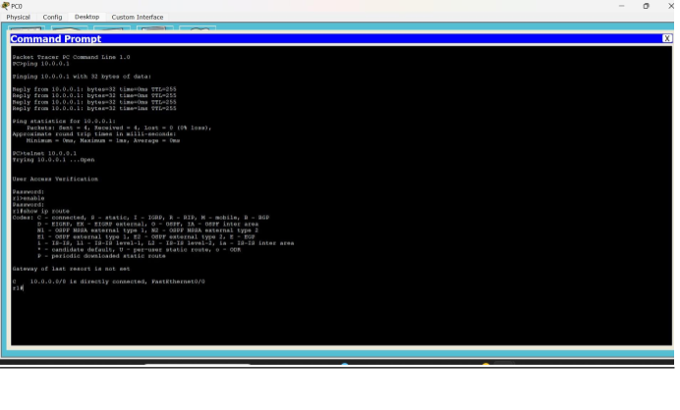

## EXPERIMENT-13

**Q) Write a program for error detecting code using CRCCCITT (16-bits)**

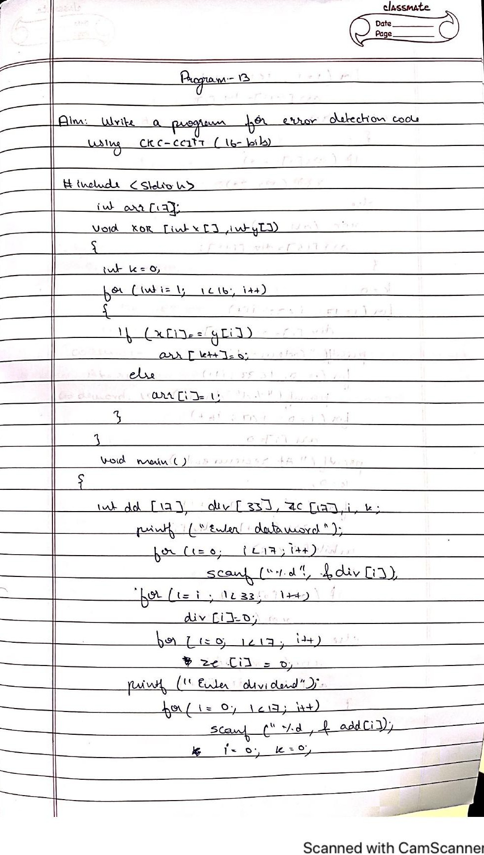

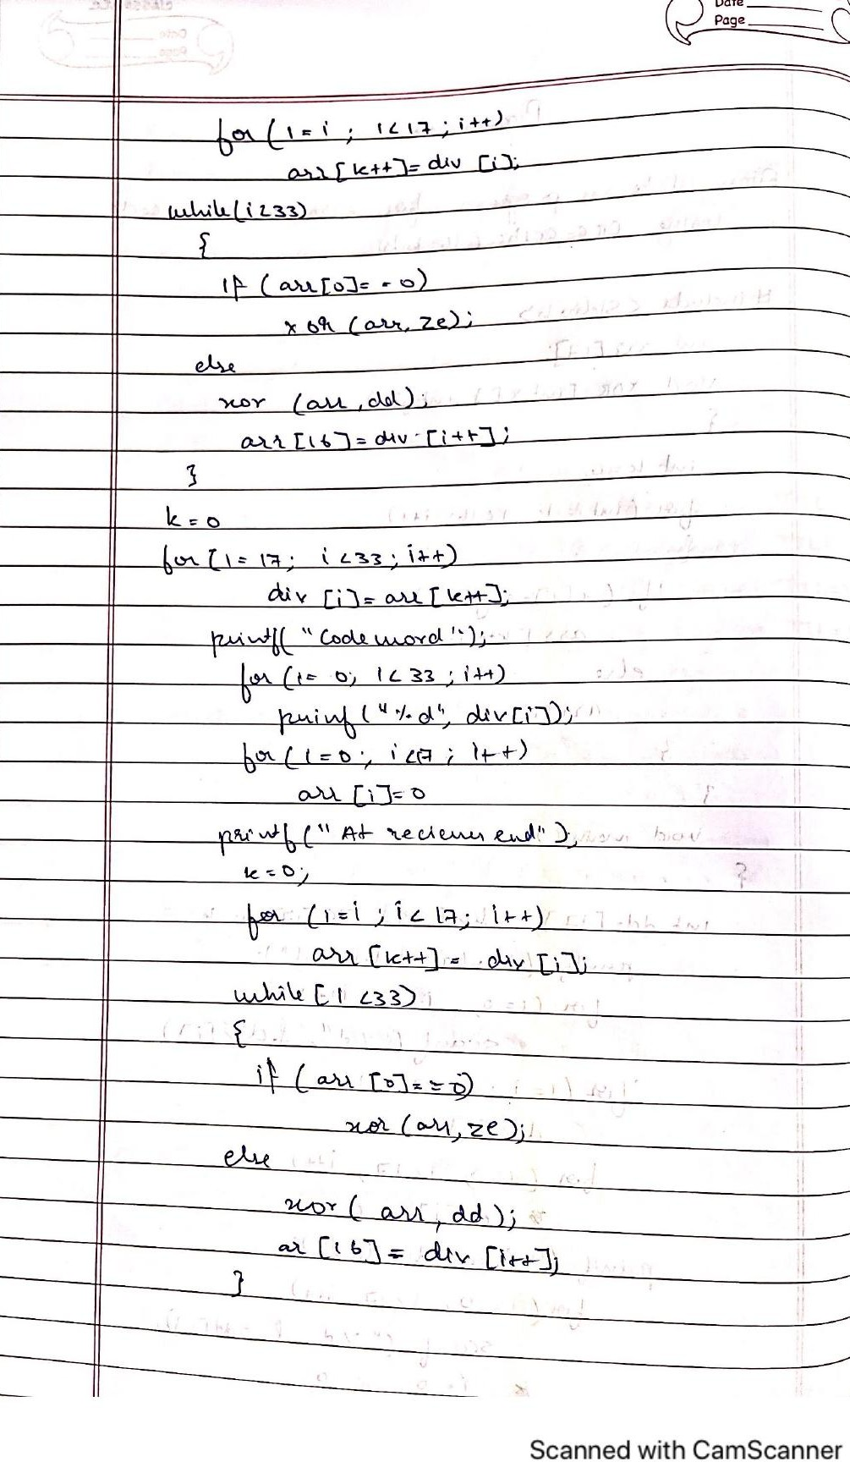

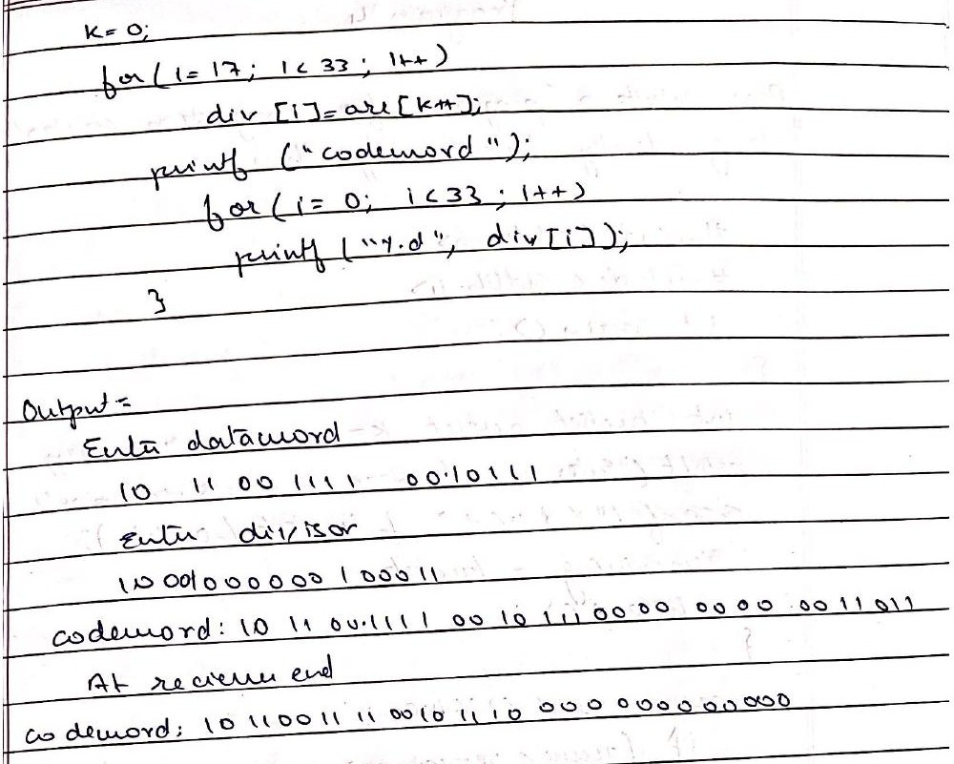

**CODE-**

import java.util.Scanner; import java.util.Arrays;

class Program {

static String Xor(String a, String b) { String result = "";

int n = b.length();

for (int i = 1; i < n; i++) { result=(a.charAt(i) == b.charAt(i))?0:1;

}

return result;

}

static String Div(String data, String key) { int pick = key.length();

String tmp = data.substring(0, pick);

int n = data.length(); while (pick < n) {

if (tmp.charAt(0) == '1')

tmp = Xor(data, tmp) + data.charAt(pick); else

tmp = Xor(new String(new char[pick]).replace("\0", "0"), tmp) + data.charAt(pick); pick += 1;

}

if (tmp.charAt(0) == '1') tmp = Xor(divisor, tmp);

else

tmp = Xor(new String(new char[pick]).replace("\0", "0"), tmp); return tmp;

}

static void Encode(String data, String key) { int lkey = key.length();

String appended_data = (data + new String(new char[lkey - 1]).replace("\0", "0")); String remainder = Mod2Div(appended_data, key);

String codeword = data + remainder; System.out.println("Remainder : " + remainder);

System.out.println("Encoded Data (Data + Remainder) :" + codeword + "\n");

}

public static void main(String[] args) { Scanner s = new Scanner(System.in);

System.out.println("enter dataword and key"); String data = s.next();

String key = s.next();

EncodeData(data, key);

}

}

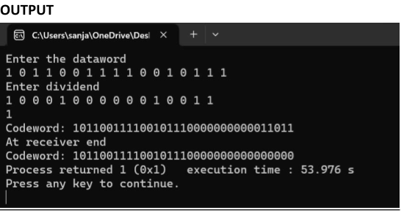

EXPERIMENT-14

**Q) Write a program for congestion control using Leaky bucket algorithm**

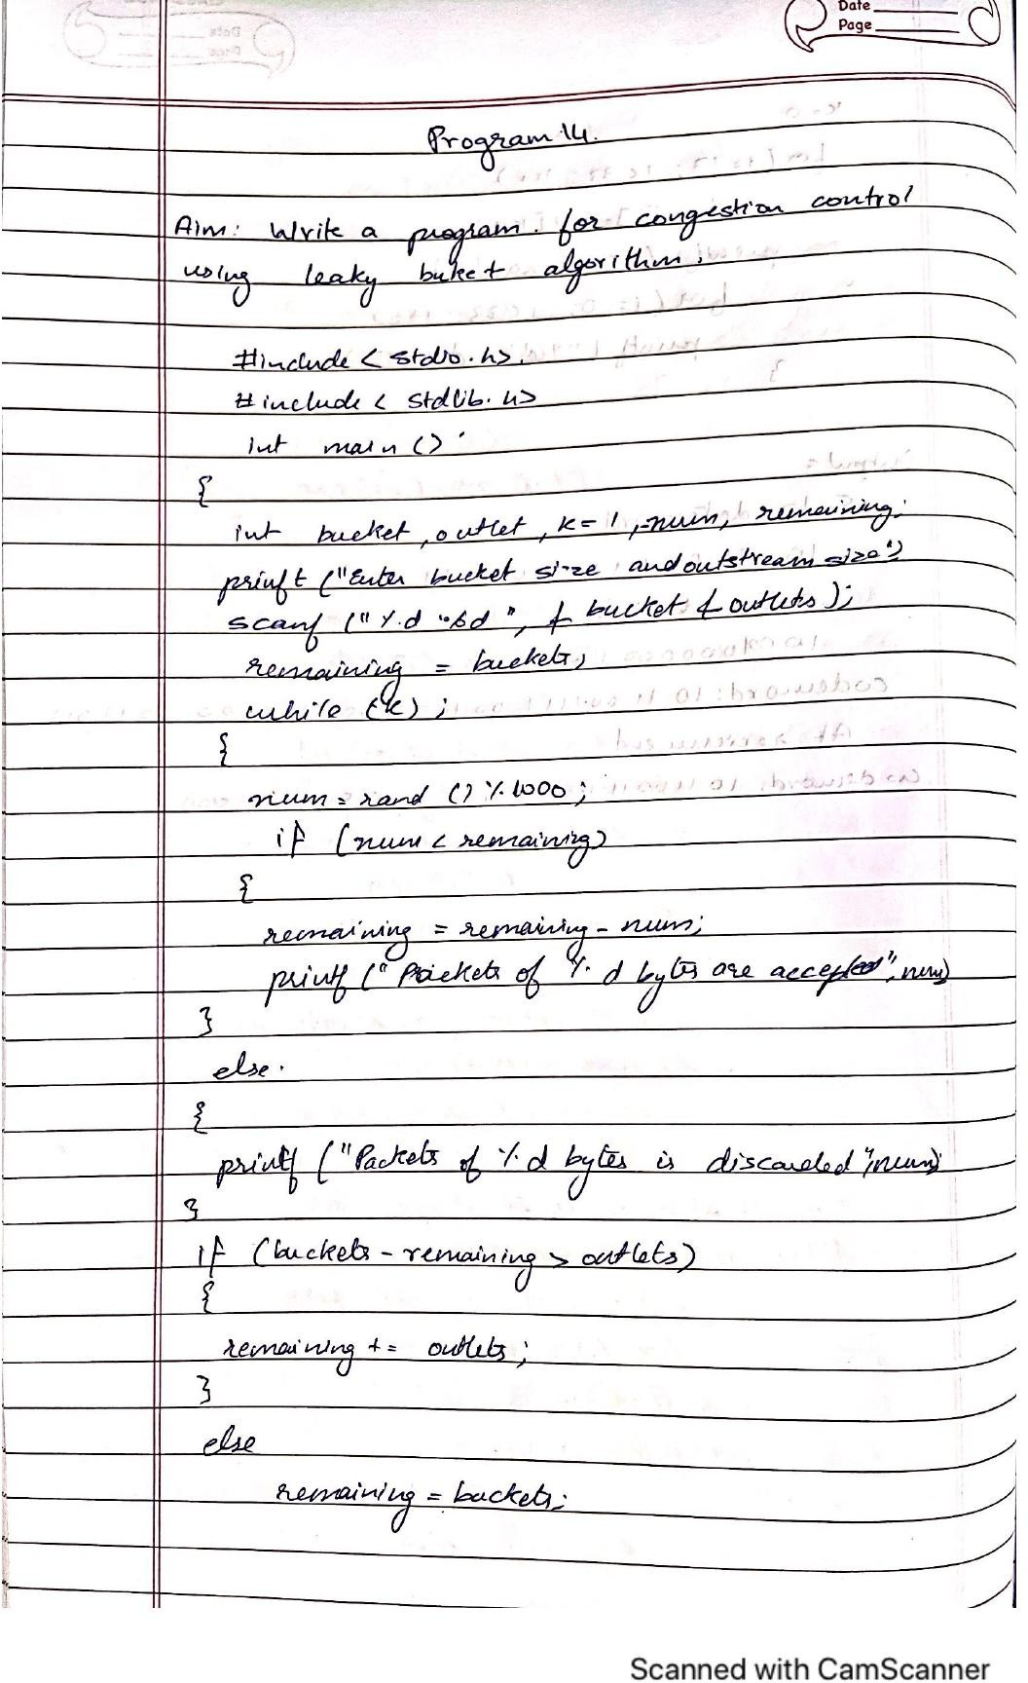

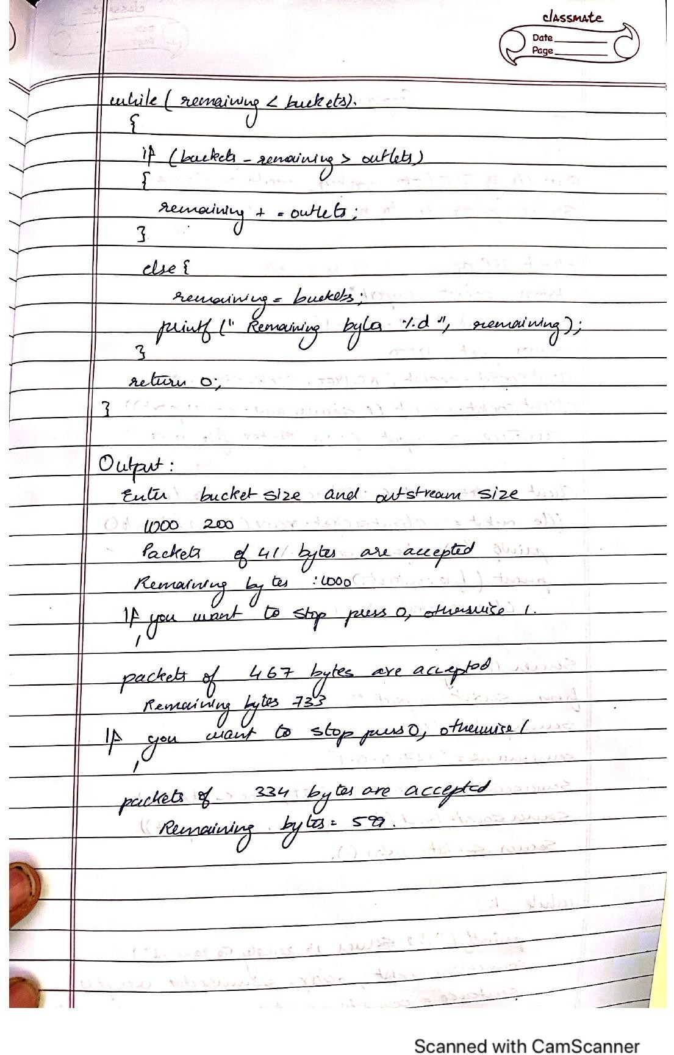

**CODE-**

import java.util.*; class Leakybucket {

public static void main(String[] args)

{

int rem;

Scanner sc=new Scanner(System.in); int s= 0;

System.out.println("enter no of queries,buffer size,input and output packet size "); int q=sc.nextInt();

int bs=sc.nextInt(); int ip=sc.nextInt();

int op=sc.nextInt(); for (int i = 0; i < q; i++) {

rem=bs-s;

if (ip <= (rem)) {

System.out.println("packet is accepted"); s+=ip;

}

else {

System.out.println("Packet not accepted ");

}

System.out

.println("remaining space="+(bs-s)); s -= op;

}

}

}

**OUTPUT**

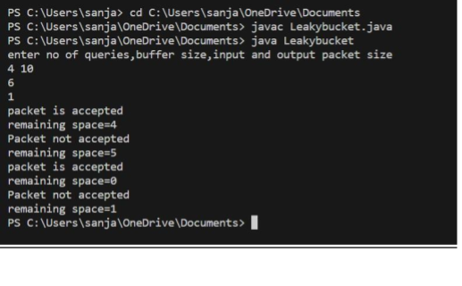

## EXPERIMENT**-**15

**Q) Using TCP/IP sockets, write a client-server program to make client sending the file name and the server to send back the contents of the requested file if present.**

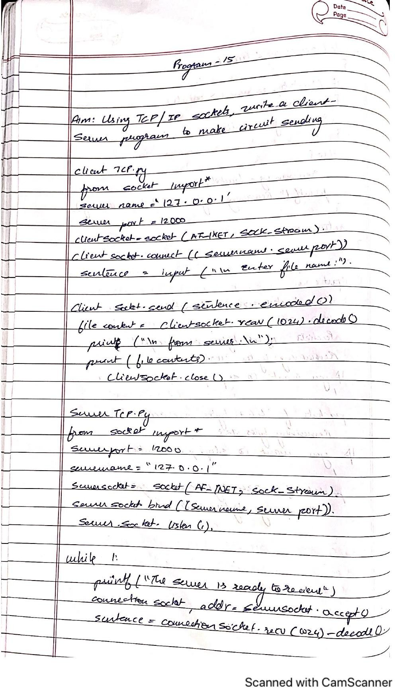

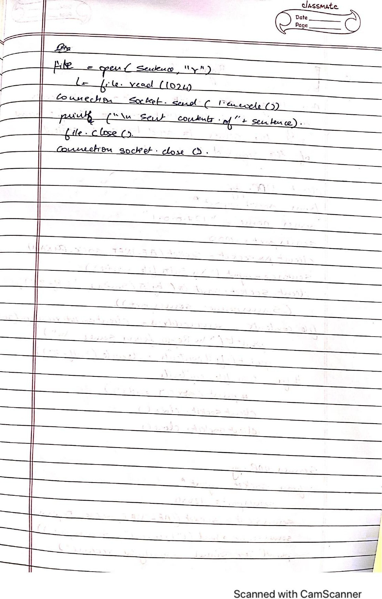

**CODE-**

**ClientTCP.py**

from socket import * serverName = "127.0.0.1"

serverPort = 12000

clientSocket = socket(AF_INET, SOCK_STREAM) clientSocket.connect((serverName,serverPort)) sentence = input("\nEnter file name:")

clientSocket.send(sentence.encode()) filecontents = clientSocket.recv(1024).decode() print ("\nFrom Server:\n")

print(filecontents) clientSocket.close()

**ServerTCP.py**

**from socket import \*** serverName='127.0.0.1' serverPort = 12000

serverSocket = socket(AF_INET,SOCK_STREAM) serverSocket.bind((serverName,serverPort)) serverSocket.listen(1)

while 1:

print("The server is ready to receive") connectionSocket, addr = serverSocket.accept() sentence = connectionSocket.recv(1024).decode()

file=open(sentence,"r") l=file.read(1024)

connectionSocket.send(l.encode()) print ("\nSent contents of " + sentence) file.close()

connectionSocket.close()

**OUTPUT**

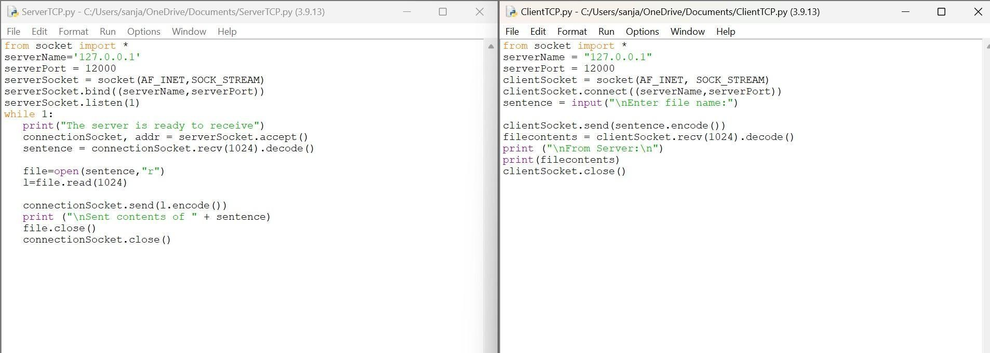

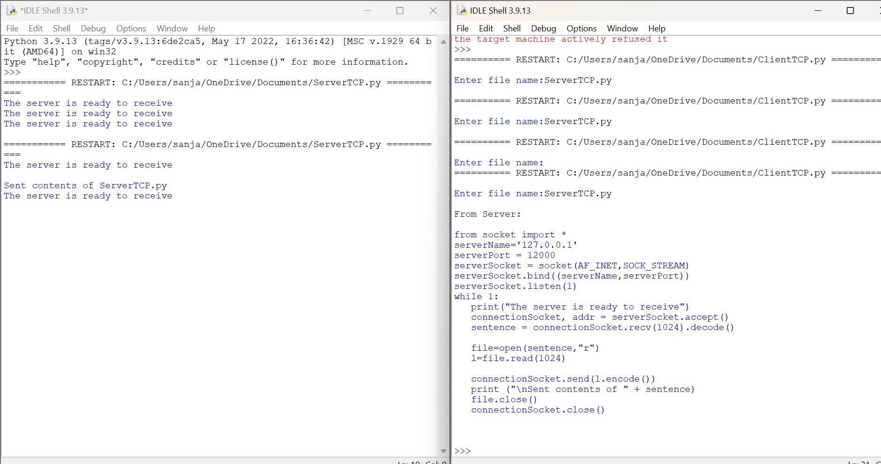

## EXPERIMENT-16

**Q) Using UDP sockets, write a client-server program to make client sending the file name and the server to send back the contents of the requested file if present**

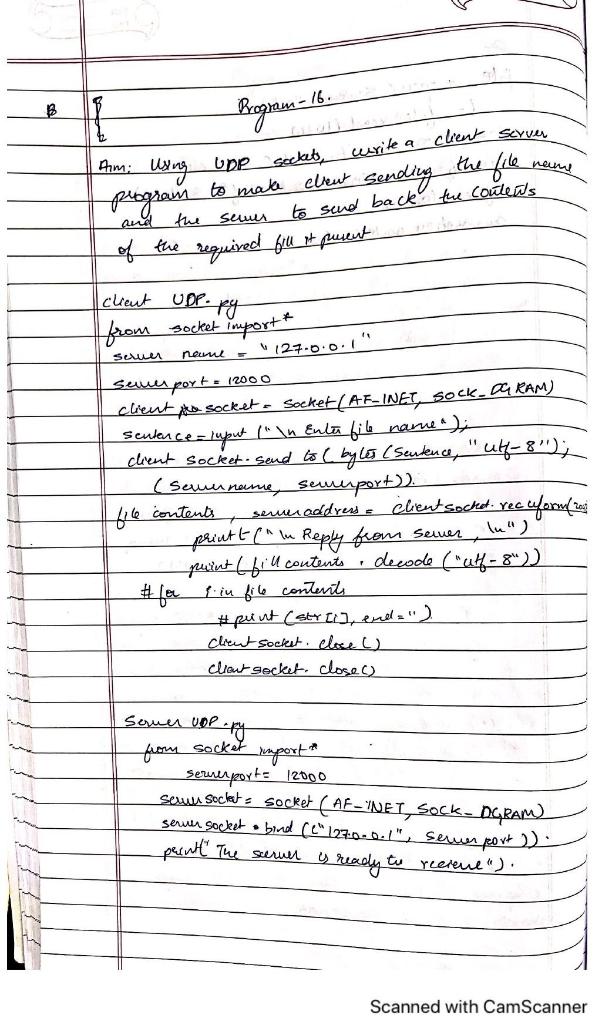

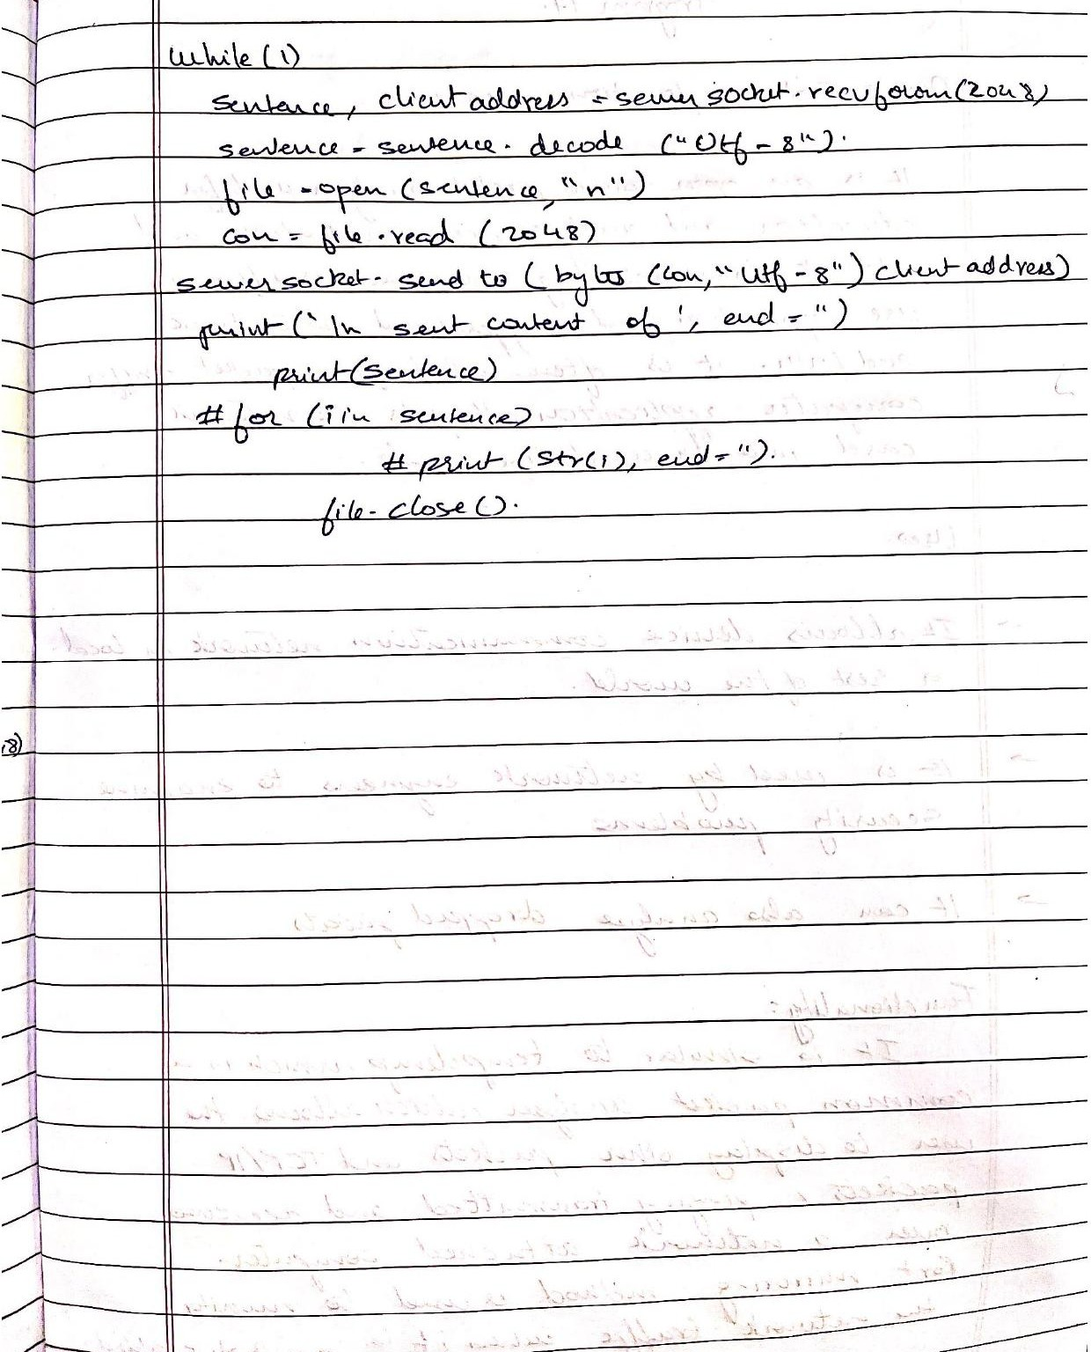

**CODE-**

**ClientUDP.py**

from socket import * serverName = "127.0.0.1"

serverPort = 12000

clientSocket = socket(AF_INET, SOCK_DGRAM) sentence = input("\nEnter file name:")

clientSocket.sendto(bytes(sentence,"utf-8"),(serverName, serverPort)) filecontents,serverAddress = clientSocket.recvfrom(2048)

print ("\nReply from Server:\n") print (filecontents.decode("utf-8")) #for i in filecontents:

#print(str(i), end =") clientSocket.close() clientSocket.close()

**ServerUDP.py**

from socket import * serverPort = 12000

serverSocket = socket(AF_INET, SOCK_DGRAM) serverSocket.bind(("127.0.0.1", serverPort)) print ("The server is ready to receive")

while 1:

sentence, clientAddress = serverSocket.recvfrom(2048) sentence = sentence.decode("utf-8") file=open(sentence,"r")

con=file.read(2048) serverSocket.sendto(bytes(con,"utf-8"),clientAddress) print ("nSent contents of ", end = "")

print (sentence)

# for i in sentence:

# print (str(i), end = ") file.close()

